Leading and Supporting the Inclusion of EAL Learners in Primary Schools

Professional Learning Booklet
2026-2027

Overview

Session One​  09:30 - 11:00​ | ​Knowledge of the EAL Learner​
Tea/Coffee​
11:00 - 11:15​
Session Two​  11:15 – 13:00 | Knowledge of Pedagogy​  (EAL and Language Acquisition)​
Lunch​
13:00 - 14:00
Session Three​  14:00 - 15:30 | Knowledge of Curriculum ​  (Learning, Teaching and Assessment for EAL Learners)​

Oide EAL Padlet

 To find our Padlet: Go to www.oide.ie, click on primary tab, click on EAL in Inclusive Education Section, click on Resources.

Key Messages
The Language Specification reflects the linguistic and cultural diversity visible in Primary schools and supports all learners in the development of their plurilingual repertoire across all languages. | The components of high-quality learning, teaching and assessment; knowledge of children and their prior learning, knowledge of pedagogy and knowledge of the curriculum, apply to all learners including EAL learners.
Collaboration among all school staff is essential for fostering an inclusive learning environment that supports EAL learners to fully access and progress through the whole curriculum. | An inclusive school culture is one that provides opportunities for EAL learners to use their home language to help them access the overall curriculum and participate fully in school life.

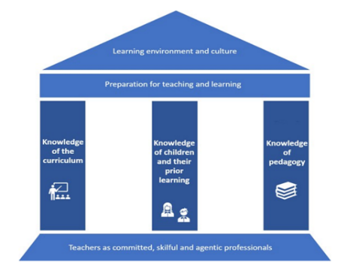

Preparation for Learning, Teaching and Assessment (updated 2026)

Session One
Knowledge of the Learner
Home Language, Culture and Identity

What resonates with you after viewing the video of Jim Cummins?

“I am a 5 year old Polish girl in Senior Infants. My parents moved to Ireland before I was born. I speak Polish at home with my family.” ​   | More about Zofia  Has an older brother in 4th Class who can read and write in Polish, English and Gaeilge.  Mixes some Polish words with English words when speaking to bilingual Polish/English speaking friends (code-switching) on the yard.  Teachers have observed Zofia has some challenges with articulation of some words.  Attends Polish School two times a week. Loves Barbie and cycling.
“I am 12 years old. I finished primary school in Brazil. My family and I moved to Ireland one month ago. We speak Brazilian Portuguese at home. I love spending time with my Mam and Dad.”   | More about Theo  Parents shared that at his previous school, he received special educational support. The school in Ireland has received his psychological report in Brazilian Portuguese.  Is very dysregulated in class and is benefitting from frequent movement breaks.  Has family friends who speak Brazilian Portuguese and English in other classes in the school.  Loves Pokémon and Minecraft.
“I am 9 years old. I am from Georgia and I live in an International Protection Centre with my parents and sister. I arrived in Ireland in November 2025 and have started to learn English.” | More about Zurab  Has moved four times since he arrived in Ireland.  There were protests outside the centre where he lives.  Attends the homework club in the International Protection Accommodation Centre.  Lived in a refugee camp in France for 1 year prior to moving to Ireland.  Excellent digital literacy, loves maths and SESE.
“I am a 7 year old Roma girl. I was born in Ireland. I started school this year. I live with my extended family. My older sister is the first person to read and write in my family.” | More about Elena  Loves to draw, paint, and listen to stories.  Excellent fine motor skills.  Did not attend early years education.  Lives in a large loving family.  Excellent receptive oral language skills in English.  Is comfortable with asking questions to seek meaning.
“I am 10 years old and I’m in Fourth Class. I’ve been in Ireland for two years. I live with my mother and my cousins. I speak Ukrainian and a bit of Russian. I love building Lego.” | More about Ihor  Experienced direct effects of war in Ukraine from March 2022 to January 2023. During this time, he engaged in remote education only.  Spent six months in Poland from January to June 2023 where he attended school prior to moving to Ireland. Began school in Ireland in September 2023 in Second Class.  Lives with his extended family in a small home.  Attends online school remotely (based in Ukraine).  Strong literacy/numeracy skills in Ukrainian and a bit of Russian, English and Polish.

Key Areas of Wellbeing Promotion - Relationships and Partnerships
In relation to your case study learner, with whom might the EAL teacher need to develop relationships and partnerships? ​
​

How can this be achieved?

Supporting Communication
See Panel 4 and 5 of Oide EAL Padlet

Session Two
Knowledge of Pedagogy
Plurilingual Repertoire Self Reflection
Languages in which I am literate at an academic level (Languages of Schooling) | Languages in which I am literate at a basic level | Languages in which I am fluent but not literate | Languages in which I can ‘have a chat’ about day-to-day things | Languages I can read but cannot speak | Languages in which I know a few words | Languages I used to know but I’ve forgotten  (Language Attrition)
Jim Cummins’ Iceberg Theory of Language Development
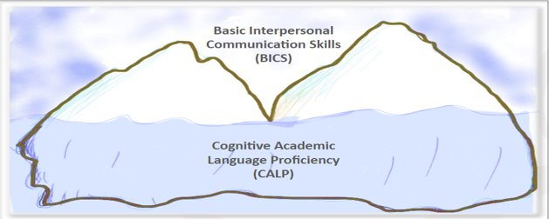 See Panel 1 of EAL Padlet

NOTES:

Session Two
Knowledge of Pedagogy
Models of Language Learning
EFL (English as a Foreign Language)​​ | EAL (English as an Additional Language)​​ | Plurilingualism​​
BICS:​​  Day to day survival language only.​​ | Scaffolding the language of the curriculum so all learners can participate.​​ | Scaffolding the language of the curriculum so all learners can participate.​​  Translanguaging approaches used.​​
Focus on the target language only.​​ | Focus on language/s and the curriculum.​​ | Focus on language/s and the curriculum.​​
Lack of exposure to target language outside the classroom.​​ | Learners are fully immersed in target language.​​ | Learners use all the languages in their linguistic repertoire.​​

Plurilingualism
See Panel 5 of Oide EAL Padlet for PPLI Primary Intercultural Guidelines

Notes:

Role of Teacher and SET/EAL Teacher

See Panel 7 & 8 of EAL Padlet

Session Two
Knowledge of Pedagogy
Stages of Second Language Acquisition
 | Preproduction | Early  Production | Speech  Emergence | Intermediate  Fluency
Appropriate expectations | Nodding,  Pointing or  physically  demonstrating | One or two-  Word  responses,  making  choices from given samples. | Phrases or short sentences (expect grammatical errors) | Longer sentences, fewer grammatical errors
Teacher questions or cues | “Show me….?”  “Which of these…?” | “Is it the _______one of the ________one?”  Questions that can be answered in one or two words | “Did this happen at the beginning or at the end?”  “What happened next?”  “Where did you find the answer?” | “How did you …?”  “What was the character trying to do?”
Adapted from Krashen & Terrell, 1983
Factors that may Affect the Acquisition of Language/s of Schooling
Intrinsic Factors*​ | Extrinsic Factors​
Age​  Aptitude  Cognitive Style  Motivation  Personality | Trauma/Wellbeing  'Distance of target language/s'​  Socio-economic conditions  Attendance/disengagement with education  Quality of education/comprehensible input

Session Two
Knowledge of Pedagogy
Pedagogical Approaches
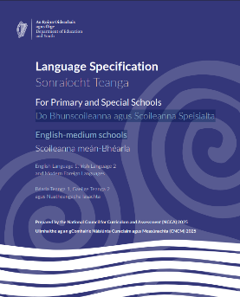
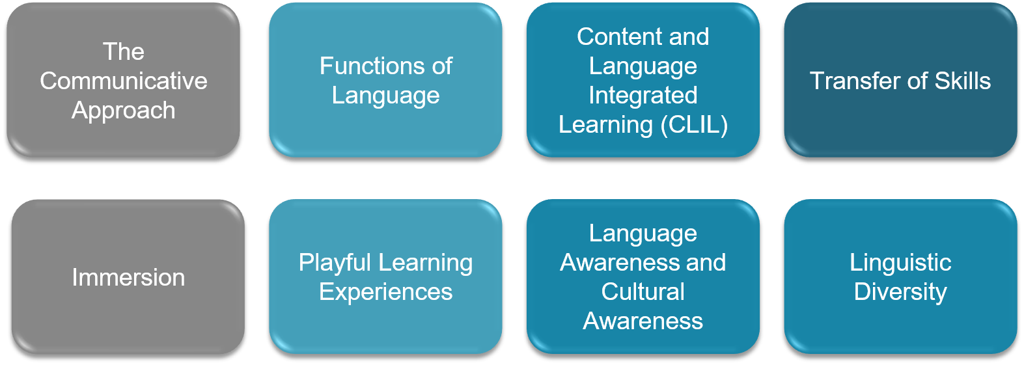
Language Specification, Section 6: The Primary language Curriculum in Practice

See Panels 7, 8 and 9 of EAL Padlet

Notes:

Session Two
Knowledge of Pedagogy
Language Specification Learning Outcomes Overview (pp.23-4)
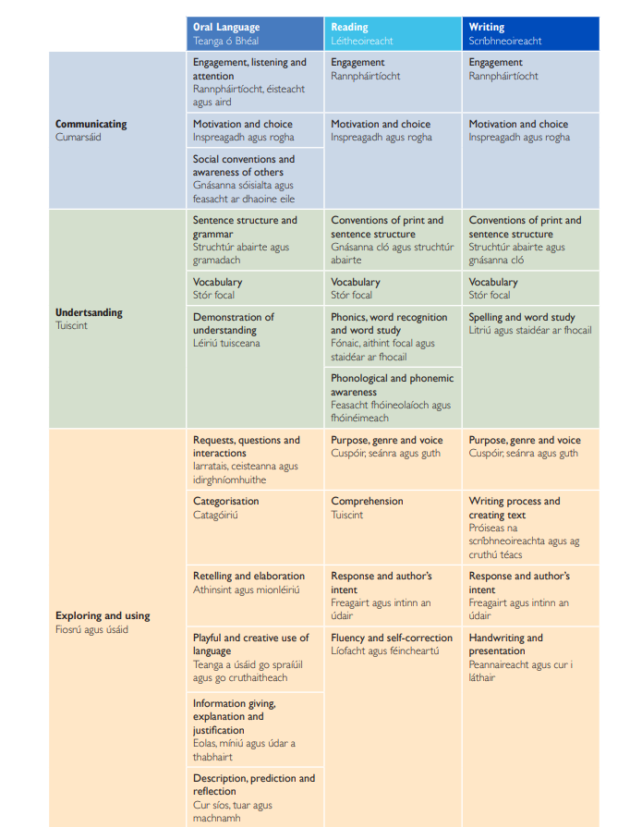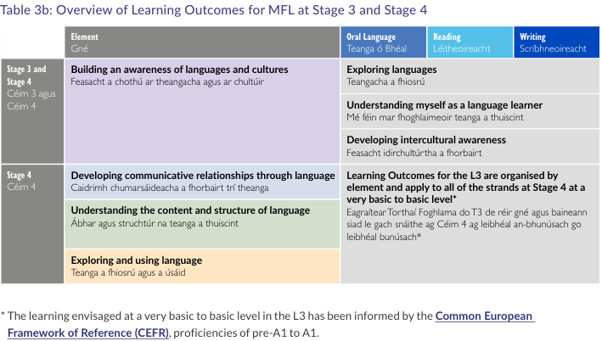

Session Two
Knowledge of Pedagogy
Language Development Learning Experiences
Binary Boards

Binary Boards can be used for all languages being taught in a school and can support oral language and writing. Learners can use them to make simple phrases with vocabulary cards (i.e., “I don’t like bananas, but I like apples.” “Rory likes apples but doesn’t like bananas.” This can support language awareness, grammar and semantics.

Learning Outcome/s that this activity could help to achieve:

Reflections on activity:

Session Two
Knowledge of Pedagogy
Language Development Learning Experiences
Colourful Semantics

Colourful Semantics is a system for colour coding sentences according to the role of different words. It can help children to break down sentences and understand the individual meaning of each word and its role in the sentence. It can help children to better understand word order.

Learning Outcome/s that this activity could help to achieve:

Reflections on activity:

Session Two
Knowledge of Pedagogy
Digital tools as a scaffold

Providing EAL learners with access to digital tools can enhance their engagement with the curriculum while recognising and valuing their home language and literacy skills as a support for learning. These tools can help learners develop comprehension across a range of genres by using their existing language knowledge as a foundation. When digital supports are used as scaffolds, learners can build an understanding of key vocabulary, concepts and text content, enabling them to transfer knowledge and meaning from their home language into English

Learning Outcome/s that this activity could help to achieve:

Reflections on activity:

Session Two
Knowledge of Pedagogy
Vocabulary Development Activities

Using scaffolds like sentence stems, sentence frames, graphic organisers, etc, learners can develop their English vocabularies in context and attain an understanding of the structure, semantics, syntax, and grammar of English in context, rather than just learning vocabulary in isolation.

Learning Outcome/s that this activity could help to achieve:

Reflections on activity:

Session Three
Knowledge of Learner
Assessment
Assessing Language Proficiency
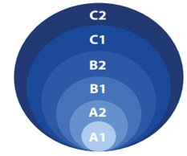 | CEFR Language Proficiency Levels (CEFR: Common European Framework for References of Languages)  See Panel 10 + 15 of EAL Padlet  “The European Commission promotes the CEFR as a credible and coherent​ framework for describing language competence levels. This supports language​ mobility and provides a sound basis for effective delivery of interventions and​ assessments for additional language learning.”  (DEY, Inspectorate Report: Meeting Additional Language Needs: Whole-school and Classroom Approaches for Inclusive Language Learning, 2024, p.35)  See Panel 10 & 15 of Oide EAL Padlet
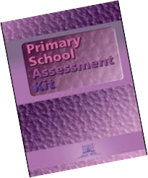 | There are three sets of assessments of the Primary School Assessment Kit (PSAK): ​  - SET 1 (Placement)​  - SET 2 ​  - SET 3​  Assessments are carried out for each of the four skills: listening, speaking, reading, and writing.​  The PSAK is the tool teachers use to assess Language Proficiency in Irish Primary Schools.  See Panel 10 & 15 of EAL Padlet

Session Three
Assessment Type | Examples in EAL Context | Further Examples
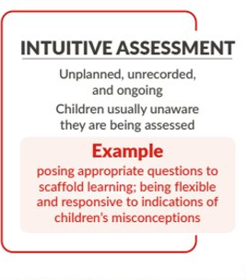  Occur naturally on an ongoing basis during learning experiences.  Can be invisible, yet still be intentional. | Observing EAL learners engage with peers in social play.  Initial development of a language and learning profile for EAL learner.  Day-to-day responsive teaching and learning that considers EAL learners use of language structures and builds on their current knowledge of language and curriculum areas.
Continuum of Assessment

Assessment Type | Examples in EAL Context | Further Examples
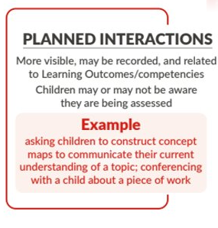  More explicit, planned.  Follow on from Intuitive Assessment | Having conversations, questioning and seeking meaning  Constructing concept maps  Graphic Organisers (concept maps) about EAL learners’ prior knowledge before a unit of work  Writing conferencing

Session Three
Knowledge of Curriculum
Continuum of Assessment
Assessment Type | Examples in EAL Context | Further Examples
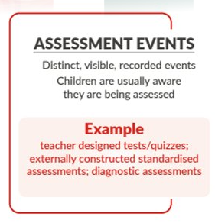  Distinct events  Almost always involve producing a record of the outcomes of the assessment  Children are aware they are being assessed. | End of unit assessment  Primary School Assessment Kit  Standardised Testing  Teachers can use a variety of ways to document assessment information, such as notes, photographs, videos, and learning stories.

Preparation for Learning, teaching and Assessment
Preparation | Considerations for EAL Learner
Invisible

Visible

Recorded

Session 3
Knowledge of Curriculum
Scaffolding Strategies for EAL Learners
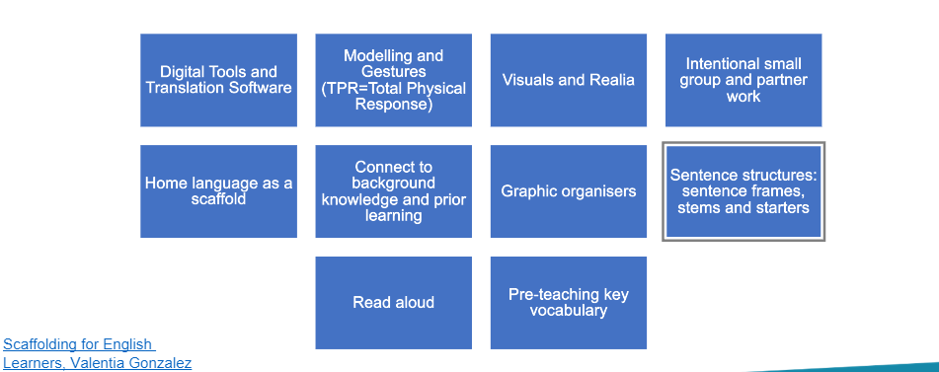
See panel 9 of EAL Padlet
What scaffolds did Moises use?
In what ways was Moises agentic in his own learning?
What impact do you think this assessment may have on Moises?
How can we, as teachers, improve EAL learners’ access to the curriculum?
See Panel 4 of EAL Padlet for Moises Immersion Video

Session 3
Knowledge of Curriculum
Scenario
Unit of Work in SEE
Subject: Geography
Strand: Europe and wider world
Strand Unit: Environment and sustainable living
Stage 4: Fifth and Sixth class

Geography Learning Outcome of Lesson:
Examine aspects of the interrelationship between Earth and other bodies in the solar system

Language Specification Learning Outcome:
Motivation and Choice: Evaluate and critically choose appropriate tools, strategies, content and topics to create text in a range of genres across the curriculum for a variety of purposes and audiences. (Solar System Project)

Geographical Skills:

- Questioning
- Investigating
- Using evidence and sources
- Interpreting and analysing
- Examining
- Assessing
- Communicating

Activities:
Criteria for successfully communicating information in project form is discussed with whole class. Purpose, Audience, Text, and images are discussed with class.
Children create KWL chart in groups on solar system.
Children work in groups to create project on solar system.

Session 3
Knowledge of Curriculum
Scenario
Assessment
WALT: Choose and use appropriate content about the solar system and convey it effectively in project format using text and images
WILF: Solar system project that clearly communicates the properties of the planets and their relative distances from each other and the sun.

Olena
Age:11 Class: 5th Nationality: Ukrainian
Linguistic Repertoire:
Languages | Oral Language Development | Academic Language Development | Language/s of Schooling
Ukrainian | Home Language | At or above expected age/stage level | Primary language of schooling
Russian | A1 | -
Polish | A1 | - | Attended school in Poland for 3 months (April 2024-June 2024)
English | A1 | - | English as a Foreign Language (EFL) for 2 years in school Ukraine (BICS only)

Session 3
Knowledge of Curriculum
Scenario
Family context: She arrived in Ireland with her older brother and mother in July 2024. Her father remained in Ukraine. Her family lost their family pet and Olena misses her father and grandparents very much. Her family home was occupied during the war and her mother has shared that Olena has been quite sad about the separation of her family. Her family are eager to reunite when it is safe for them to return.

Hobbies, interests, favourite subjects: Excels at mathematics and the arts. She plays the piano, studies ballet and paints. Her family would describe her as creative, shy, and kind. Olena loves to read and watch films in Ukrainian.

Disposition: She can at times be shy and needs encouragement to participate in the mainstream class but will engage in oral work in small groups.

Home language education: She has continued with Ukrainian school online in the mornings for one hour and in the afternoons for two hours when she arrives home from school. There are two other Ukrainian students in Olena’s class who have been in Ireland and attending the school.

Available Supports: The school has other Ukrainian students who have attended since May 2024. There is a SET/EAL teacher who can support Olena and other EAL learners in the school.
Two other families in the same school from Ukraine live in the same accommodation centre as Olena, and their parents are friendly. Olena travels to and from school by taxi each day from the accommodation centre with them. There is a Ukrainian/English speaking parent who supports the Ukrainians in the centre who can support the communication between home and school. The school has the use of tablets for digital tools and broadband connection.

Session 3
Knowledge of Curriculum
Scenario
What are the considerations for preparation for learning, teaching and assessment for SET/EAL teacher and class teacher?
Consider:
How can Olena access this unit of work?
What language learning opportunities are there?
What types of activities might she engage in?

Session 3
Knowledge of Curriculum
Scaffolding EAL Learners

What Key Competencies from the Primary Curriculum Framework, (PCF), might Olena be developing during this unit of work?

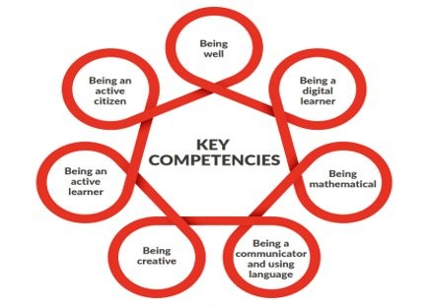

Reflection and Next Steps….

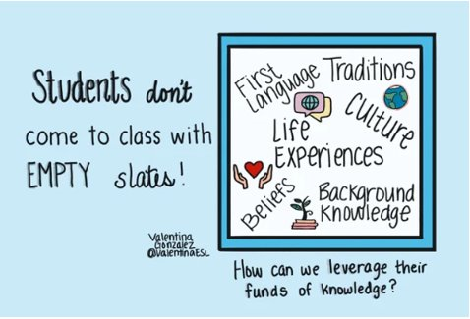

References
Binogi Pedagogiskt Forum (2018) Jim Cummins on language and identity. 7 November 2018. Available at: https://www.youtube.com/watch?v=xuvFaNgAv88

Celic, C., Seltzer, K. (2012, Revised 2013) Translanguaging: CUNY-NYSIEB Guide for Educators. New York: CUNY-NYSIEB. Available at: https://www.cuny-nysieb.org/translanguaging-resources/translanguaging-guides/

Clifton, Donald O. (1950-1969) Quotation: "What will happen when we think about what is right with people rather than fixating on what is wrong with them?" Available at: https://business.unl.edu/news/don-clifton-legacy/?contentGroup=clifton_strengths_institute&regionName=tile

Council of Europe (2020), Common European Framework of Reference for Languages: Learning, teaching, assessment – Companion volume. Strasbourg: Council of Europe Publishing. Available at: www.coe.int/lang-cefr

Cummins, J. (1979) Cognitive/academic language proficiency, linguistic interdependence, the optimum age question and some other matters’, Working Papers on Bilingualism 193(10), pp. 3147-3167. Available at: https://eric.ed.gov/?id=ed184334

EAL Team SIS (2014) The importance of ELL strategies Immersion (Moises in Math Class). 10 August 2014. Available at: https://www.youtube.com/watch?v=D6HUv2eFdLg

Ellis, R. (2015) Understanding second language acquisition 2nd edition. Oxford University Press. Available at: https://global.oup.com/academic/product/understanding-second-language-acquisition-9780194422048?lang=en&cc=de

Gibbons, P. (2015) Scaffolding language, Scaffolding Learning: Teaching English language learners in the mainstream classroom 2nd Edition. Portsmouth, NH: Heinemann. 1st Edition available to download as PDF: https://www.scribd.com/document/262867132/Gibbons-Scaffolding-Language-Scaffolding-Learning

Gogolin, I., Keiner, E., Steiner-Khamsi, G., Ozga, J., & Yates, L. (2007). Knowledge and Policy: Research — Information — Intervention. European Educational Research Journal, 6(3), 283-302. Available at: https://doi.org/10.2304/eerj.2007.6.3.283

Gonzalez, V. (2020) Empty Slate Infographic. Available from: https://www.valentinaesl.com/store/p14/EmptySlate.html

Ireland: Department of Education and Science (2007) Special Educational Needs: A Continuum of Support (Resource Pack for Teachers) Dublin: NCSE (National Council for Special Education) Available at: https://www.sess.ie/special-education-teacher-allocation/primary/continuum-support-primary

Ireland: Department of Education, the National Council for Curriculum and Assessment, Professional Development Services for Teachers and the National Council for Special Education (202). Preparation for Learning, Teaching and Assessment - Updated Guidance for All Primary and Special Schools. Ullmhúchán don Teagasc agus don Fhoghlaim - Treoir do gach Bunscoil agus Scoil Speisialta (Ireland). Dublin:

NCCA. Available at: https://ncca.ie/en/primary/preparation/
Ireland: Department of Education and the National Council for Curriculum and Assessment (2025). The Primary Curriculum Framework (Ireland). Dublin: NCCA. Available at: https://www.curriculumonline.ie/Primary/The-Primary-Curriculum-Framework/

Ireland: Department of Education and Youth (2025). The Primary Language Specification (Ireland). Dublin: DEY. Available at: https://www.curriculumonline.ie/primary/curriculum-areas/updated-language-curriculum/)

Ireland: Department of Education and Skills (2018). Wellbeing Policy Statement and Framework for Practice 2018–2023, Revised October 2019. Dublin: Department of Education. Available at: https://assets.gov.ie/24725/07cc07626f6a426eb6eab4c523fb2ee2.pdf

Kirwan, D., 2015. Learning outcomes in plurilingual environments: Reflections on curriculum, pedagogy and assessment. Dublin: National Council for Curriculum and Assessment (NCCA). Available at: https://ncca.ie/media/2127/learning-outcomes-in-plurilingual-environments-reflections-on-curriculum-pedagogy-and-assessment.pdf

Krashen, S.D. and Terrell, T., 1983. Natural approach (pp. 20-20). New York: Pergamon. Available at: https://web.stanford.edu/~hakuta/www/LAU/ICLangLit/NaturalApproach.htm

Little, D., Lazenby Smith, B. (2006) Up and Away: A Resource Book for English Language Support in Primary Schools. Dublin: Integrate Ireland Language and Training. Available at: https://ncca.ie/en/resources/up_and_away/

Little, D., Lazenby Simpson B., Finnegan Ćatibušić , B. (2006) Primary School Assessment Kit (PSAK). Dublin: Integrate Ireland Language and Training. Available at: https://ncca.ie/media/2172/primary-school-assessment-kit.pdf

Little, D. and Kirwan, D., (2021) Language and Languages in the Primary School: Some Guidelines for Teachers. Dublin: Post-Primary Languages Initiative (PPLI). Available at: https://ppli.ie/ppli-primary-guidelines/

Long, M. (1988) Understanding Second Language Acquisition, Rod Ellis. Oxford: Oxford University Press, 1985. Pp. 327.,” Studies in Second Language Acquisition. Cambridge University Press, 10(1), pp. 79–82. Available at: https://www.researchgate.net/publication/275188906_UNDERSTANDING_SECOND_LANGUAGE_ACQUISITION_Rod_Ellis_Oxford_Oxford_University_Press_1985_Pp_327

Oide (2025/2026) Oide Primary EAL Padlet. Available at: https://oide.ie/primary/home/inclusive-education/eal/resources/

Slaughter, Y. and Cross, R., 2021. Challenging the monolingual mindset: Understanding plurilingual pedagogies in English as an Additional Language (EAL) classrooms. Language Teaching Research, 25(1), pp.39-60. Available at: https://journals.sagepub.com/doi/full/10.1177/1362168820938819

