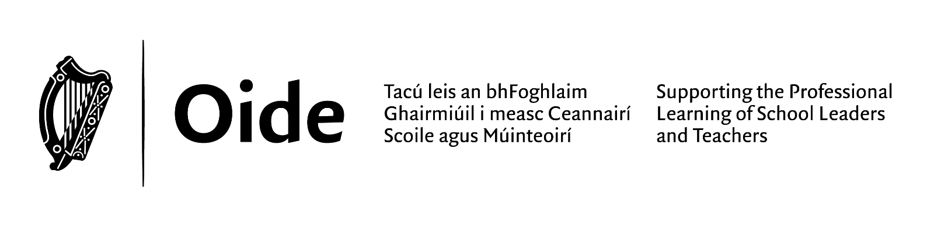
Fostering an Inclusive School Culture

Professional Learning Experience (PLE) 2025-2026
School:
Date of Seminar:
Venue:
Session 1​ | Understanding Inclusion
Tea/Coffee​
Session 2​ | Promoting a Sense of Belonging for all Learners​  Inclusive Pedagogical Approaches​
Lunch​

Session 3​ | Building Relationships and Partnerships​  Whole School Approach and Leadership of an Inclusive School​

Session 1: Understanding Inclusion

Reflection on Inclusion

Key Messages

Inclusive school cultures value learners as individuals and encourage them to achieve their potential. | Diverse school communities promote opportunities for all learners to develop skills necessary to participate actively in society.
School culture, relationships, partnerships, policy, planning and curriculum influence learners’ sense of belonging. | Fostering a culture of inclusion involves collaboration and partnership with staff, learners, parents, and external agencies.

What are we doing as a whole school?
What am I doing in my classroom?
Session 2: Promoting a Sense of Belonging for all Learners & Inclusive Pedagogical Practices
Reflection on Inclusive Pedagogical Practices
What are we doing well?

What might we begin to progress in our school?

Session 3: A Whole School Approach

Reflecting on whole school approaches for Inclusion
What?  Consider ONE area for development | How?  Consider how we can use these approaches
- understanding inclusion  - school and classroom culture  - building a sense of belonging  - teaching, learning and assessment processes  - curriculum  - pedagogical approaches  - partnerships  - school policies and inclusion | - creating buy- in from all stakeholders  - developing knowledge and awareness –professional learning  - distributing leadership  - seeking feedback from all stakeholders  - monitoring initiatives  - using the SSE way of working  - communicating clearly  - modelling Values  - engaging in dialogue  - mentoring

Session 3: A Whole School Approach

When?
What can we this month?

This term?

This school year?

Oide.ie– Primary – Inclusive Education – DEIS and Social Inclusion-Resources
