Religious Education Student Learning Log

Leaving Certificate
Religious Education Coursework
Table of Contents Page
About this Student Learning Log 3
My Prescribed Title 4
My Sources 5
CARRDSS Bookmark 6
Engaging with your Sources 7-8
Perspectives 9
The Steps and Skills I used 10
Example of Outlining a Step and Showing How You Used Your Skills 11
Summary of my Findings 12-13
My Personal Reflection on Learning, Skills and Experiences 14-16
Check-in on my Learning 17
Appendices 17
Appendix A: CARRDSS Bookmark 18
Appendix B: SQ3R Strategy 19
Notes 20

About this Student Learning Log
This learning log is intended to support learning by capturing the flow of a student’s work throughout the Religious Education coursework journey. It is designed to be an interactive document (used as a hardcopy or as a shared soft copy on a digital platform such as Google Classroom or Microsoft Teams) where students make regular entries relating to the work undertaken. The teacher and peer feedback that students receive will also be recorded on the document along with the next steps they will take to progress their work. Each table is expandable and can be duplicated multiple times. The information recorded in this student learning log will greatly assist the writing of drafts for Sections A and B of the coursework journal. There are strategies to support effective research outlined in appendices.

My Prescribed Title
Before you begin writing, it is important to consider the titles available to you and choose one. The table below will help you to choose and unpack your title.
Name of Section:
The title I have chosen:
What are the keywords in the title?
Why are they important?

Have I come across any of these keywords before? Where and when?

What initial questions does this title raise for me?

Why was this title interesting to me?

Learning objectives from the section in the syllabus the chosen title comes from:
(Teacher input here)

Teacher feedback on initial scoping activity:

Based on this feedback, I have decided to do the following:

My Sources
You will be required to use sources of information for your coursework. Here is a list of possible types of sources you may come across in your research on your chosen coursework title:
- Newspapers/magazines
- Websites
- Encyclopaedia
- Interviews
- Documentaries/films
- Artifacts/objects
- Social media
- Architecture/places of interest
- Maps
- Other
Wikipedia is not recognised as a reliable source of information
It is important to check the reliability of the sources you use in the research of your coursework title. This will ensure the credibility and quality of the sources you engage with. The image on the next page provides a strategy to help you decide whether a source is reliable or not. You can find more detail on this image in Appendix A.

CARRDSS Bookmark
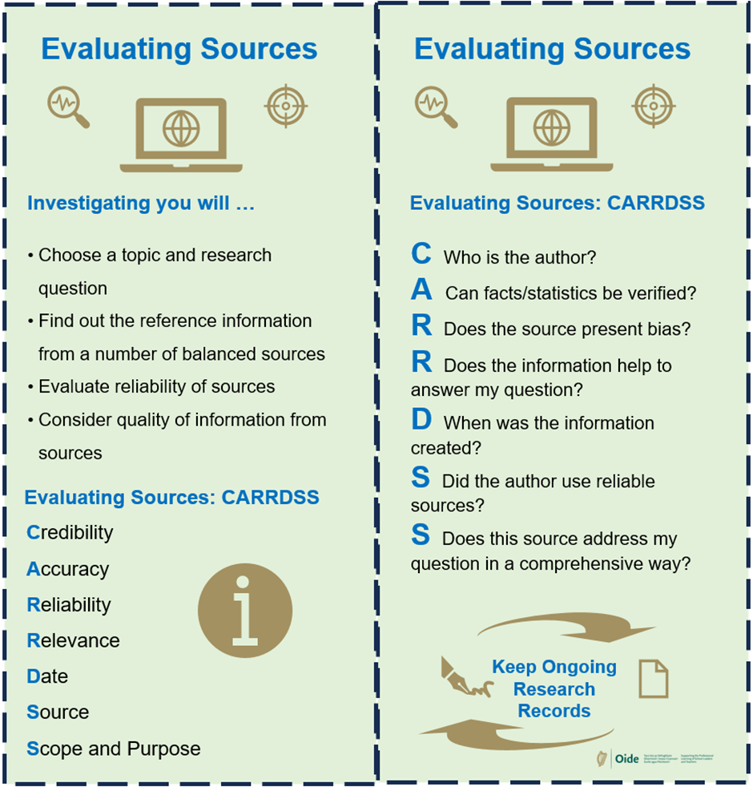

Engaging with your Sources
Here are some prompts that may help you to analyse the sources you engage with through your research on your chosen coursework title. In your reading of written texts, you may like to use the SQ3R strategy as outlined in Appendix B. This strategy will support you to closely examine the text and help you to recall important details relevant to your chosen title. This table can be copied as many times as you need to evaluate each of your sources.
Title:
Author (or host/producer):
Publisher:
Year of publication (or release date):
URL (if accessed online):
Date accessed:
Source type (book, article, podcast etc):

Did the author use reliable sources? How do I know?

Does the source present bias?

Can the facts or statistics be verified? If so, how?

What have I learned from this source that is relevant to my coursework title?

How relevant was this source to my coursework title? In what ways is it relevant?
What perspectives does it offer? (A perspective is a lens or viewpoint through which something is understood, for example a religious or secular perspective.)

Is this a perspective I have come across before? If so, where?

Can I connect what I have learned here to another source I have engaged with?
Is there anything extra I would like to note about this source?

Teacher feedback on sources:

Based on my feedback, I have decided to do the following:

Perspectives
Throughout your coursework, when you engage with various sources, you will encounter different ways of thinking about your chosen title. A religious perspective for example, might represent a particular perspective or viewpoint from a world religion or denomination within a world religion. On the other hand, perspectives may also be non-religious, for example, secular or scientific perspectives. The section below helps you to detail the different perspectives you came across in your research for this title. This table can be copied as many times as you need to in order to help you to examine the perspectives you encounter.
Perspective i.e., religious, non-religious, etc.
Source I found this perspective in:
Author (host/producer): Date accessed:
URL (if accessed online):
Chapter/section:
This perspective developed my learning on this coursework title because …
Or
I decided this perspective was not relevant to my research because …
I found this perspective interesting because:
Teacher feedback on perspectives:
Based on this feedback I have decided to do the following:
The Steps and Skills I used

You are expected to outline the steps you took in the investigation of this coursework and the skills you developed in doing so. As you engage with your coursework, it will be important to record the skills that you used in investigating your chosen title. Feel free to include challenges, opportunities or difficulties you experienced while working on this coursework and the steps you took to overcome these challenges as this will be evidence of problem-based learning. The steps and skills you outline must link to your chosen coursework title.
For example, a skill that may be developed through the completion of the coursework is critical thinking. This is the ability to think clearly, engage in reflective and independent thinking and to make use of the information to solve problems. You may use critical thinking when double checking the reliability of a source or a particular finding you come across.
Listed below are some of the skills that you might draw on and develop through the coursework:
Skills of research | Using computers, libraries, surveys or media.
Ability to select, analyse and evaluate information | Choosing reliable information and finding arguments to support or challenge your ideas.
Critical thinking | Questioning the credibility and authority of sources of information.  Distinguishing between facts and opinion.
Communication | Sorting and editing information making it your own.  Presenting ideas clearly and concisely.
Reflection | Thinking about how our own learning has influenced or changed our ideas.
Developing counter-arguments | To respond to arguments or viewpoints in a way that is informed by reliable information and facts.
Other skills
Example of Outlining a Step and Showing How you Used Your Skills

As my chosen title required me to investigate this topic, an important step I took during this coursework was to interview (name of person) as a source of information about this title. Before this interview I prepared a list of questions relevant to my coursework title and then arranged to interview (name of person) at their earliest convenience. The reason for preparing the questions beforehand was to maximise the opportunity of the interview by finding out as much information as possible on my chosen title. This preparation helped to develop my organisational skills which are important in completing this research.
The next step involved skills of analysis when I looked back over my notes from the interview and assessed the information gathered to find what was relevant and what I use as findings in my research.

The table below will help you to outline the steps you take and the skills you developed in doing so. It is important that the steps and skills you outline here link to your coursework title. This table can be copied as many times as you need to help you to outline the steps you used.
A step I took:
The skills I used in undertaking this step:

How did using these skills help my research and learning on this title?

What challenges, opportunities and/or difficulties did I find when taking this step?

Teacher feedback on the steps and skills used:
Based on my feedback I have decided to do the following:

Summary of my Findings
A summary of findings is an overview of the significant things you found out that are relevant to your chosen coursework title. Here is an example of a finding on a previous title related to scientific and religious responses to the beginnings of life.
Whilst religion and science may differ in the discussion around the beginnings of human life, they also have areas of commonality. Whereas religion asks WHY questions, science asks HOW questions. I discovered that where religion tries to explain the purpose of things, science tries to show how things happen by referring to facts, processes and methods.

The space below will help you to record the key discoveries and learning you make throughout your research. This table can be copied as many times as you need to examine each of your findings.
A finding from my research:
Where I sourced this finding:
Name:
Author (or host/producer):
Date accessed:
URL (if accessed online):
Chapter/page/section:
An interesting and relevant finding from my research is:

You may like to include personal insights or questions that arose for you when you discovered this interesting finding on p.14 of this learning log.
 | I came to the following realisation/understanding when I read/watched….
How does this connect with the other things I have learned about this topic?

Teacher feedback on this finding(s):

Peer feedback on my finding(s):

TELL …  something you liked |  | ASK …  a thoughtful question | GIVE …  a positive suggestion
I like how …  I think your example is …  The strongest point is …  I connect with …  I enjoyed … |  | Did you consider …?  What did you mean when you said …?  How do/will …?  How can you …?  Why is …? | One suggestion is …  I am confused by … I think you should add …  You might want to change/delete …  Something that might be improved is …
Based on this feedback I have decided to do the following:

My Personal Reflection on Learning, Skills and Experiences

The table below includes prompts (sentence stems) to help you structure your personal reflection on what you have learned, skills you have developed and experiences you have gained through the investigation into your chosen coursework title. The prompts in each of the sections below are suggestions, and you do not need to use them all.
5-4-3-2-1 Reflection Activity
5 questions that arose for me during coursework research:

I'm interested in knowing whether ...
I'm curious/eager to find out ...
I'm contemplating/questioning/pondering whether ...
I'm exploring whether ...
I'm intrigued by the thought of ...
I'm inquisitive about ...
I'm keen to understand/curious to see if ...
I'm interested to see whether ...
I'm wondering whether ...
4 personal insights I gained through doing my coursework:

In my opinion ...
From my perspective ...
Reflecting on this, I believe ...
I find myself questioning ...
I'm still exploring my thoughts on ...
What strikes me as crucial is ...
I strongly feel that ...
This resonates with me because …
3 perspectives I encountered in my coursework were:

The first perspective I encountered was … from … (name the source)
The second perspective I encountered on the title was …
A perspective that interested me was …
Lastly, a perspective that I agreed with was … because …
2 of the most valuable parts of doing my coursework:

Without a doubt ...
It's clear to me that ...
I'm still exploring my thoughts on ...
I can draw a parallel between ...
What strikes me as crucial is ...
It's essential to recognise that ...
This is significant because ...
I strongly feel that ...
I developed my skills of …
1 developed reason why title was of interest to me:
This title resonates with me because ...

Teacher feedback on insights:

Peer feedback on insights:

TELL …  something you liked | ASK …  a thoughtful question | GIVE …  a positive suggestion
I like how …  I think your example is …  The strongest point is …  I connect with …  I enjoyed … | Did you consider …?  What did you mean when you said …?  How do/will …?  How can you …?  Why is …? | One suggestion is …  I am confused by …  I think you should add …  You might want to change …  Something that might be improved is …
Based on this feedback, I have decided to do the following:

Check-In on my Learning
At this point in your coursework, it may be useful to take stock of your learning so far.
Consider:
- How much more informed am I about the topic I have studied?
- How did this happen?
- Is there information I still want to find?
- Did I use strategies to support my research, such as CARRDSS to help evaluate sources or the SQ3R method of close reading.
- Have any of my beliefs/ ideas/ attitudes been challenged influenced or changed because of my research?
- What skills have I developed?
- What significant observations have I made?
- Did any challenges come up for me? How did I address them?
- Did I engage with all the key words in the title?
- Did I distinguish between fact and opinion?
- Can I name at least two different perspectives I came across in the course of my research?

Appendices
Appendix A: Evaluating the Reliability of Sources CARRDSS
The CARRDSS approach outlined below is helpful when trying to evaluate (judge) the reliability of a web-based source of information. This page can be printed separately to make the bookmark. (Fig.1)
Appendix B: SQ3R to support close reading of texts
SQ3R is a strategy that supports close reading of texts to help you recall important information. A close reading allows you to see the key details within a text that are relevant to your research. Try using it when engaging with sources of information that are written texts. (Fig.2)
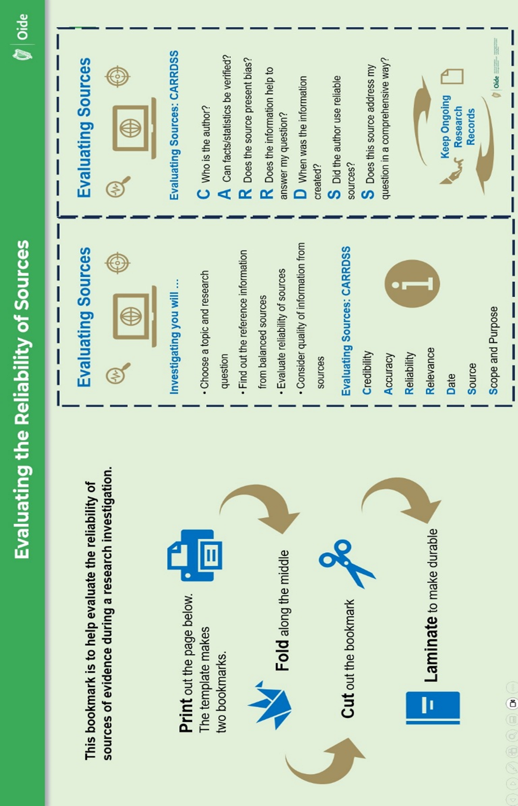
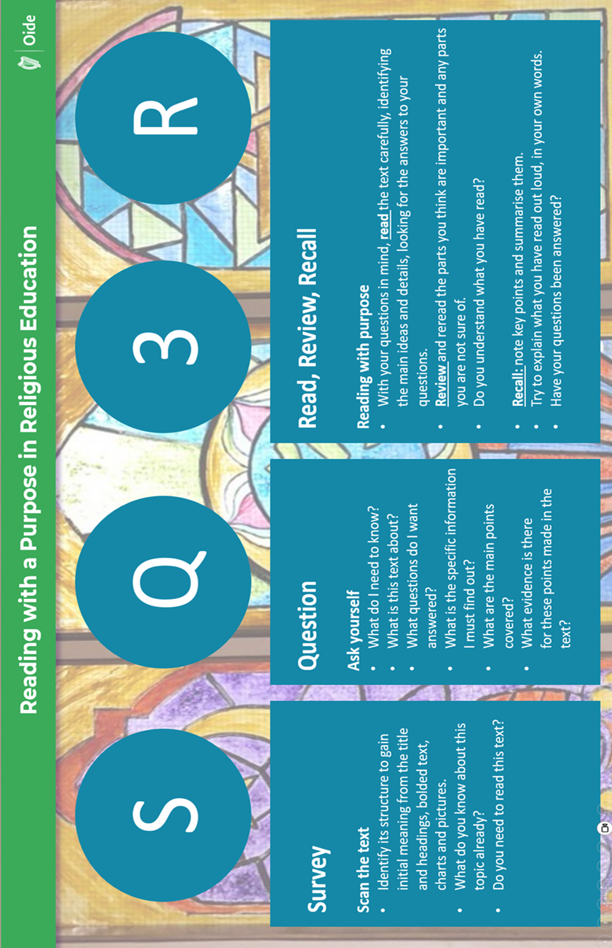
Notes

