Thinking through Teaching (How?) and Learning (What?) Half-Term Plan
Date: _________________ Year Group: ___________________
Week | Content/Topic  What Element of the Syllabus or Specification? | Learning Intentions  Differentiation  Students will be able to… | Methodologies  Activities  What I do to facilitate learning... | Assessment for (AfL) & of (AoL) Learning  Testing/ Questioning/ Checking Learning | Text Resource ICT | Literacy & Numeracy Supports | Assignments/Homework  Pre-Learning for Next Class
1
2
3

Thinking through Teaching (How?) and Learning (What?) Half-Term Plan
Date: ________________ Year Group: _________________
Week | Content/Topic  What Element of the Syllabus or Specification? | Learning Intentions  Differentiation  Students will be able to … | Methodologies  Activities  What I do to facilitate learning... | Assessment for (AfL) & of (AoL) Learning  Testing/ Questioning / Checking learning | Text Resource ICT | Literacy & Numeracy Supports | Assignments /Homework  Pre-learning for Next Class
4
5
6

Sample Weekly Plan: Thinking through Teaching (How?) and Learning (What?)
Date: ___________________________ Year Group: _________________________
Day | Content/Topic  What Element of the syllabus or specification? | Learning Intentions  Differentiation  Students will be able to… | Methodologies  Activities  What I do to facilitate learning... | Assessment for (AfL) & of (AoL) Learning  Testing/Questioning/ Checking learning | Text  Resource  ICT | Literacy & Numeracy Supports | Assignments/Homework  Pre-learning for Next Class
Mon
Tues
Wed
Thurs
Fri

Sample Weekly Plan: Thinking through Teaching (How?) and Learning (What?)
Date: ____________________________ Year Group: _________________________

Day | Content/Topic  What Element of the syllabus or specification? | Learning Intentions  Differentiation  Students will be able to … | Methodologies  Activities  What I do to facilitate learning... | Assessment for (AfL) & of (AoL) Learning  Testing/Questioning/ Checking learning | Text  Resource  ICT | Literacy & Numeracy Supports | Assignments /Homework  Pre-learning for Next Class
Double
Single
Single
Single

Sample Weekly Plan  Date: | Content/Syllabus or Specification |  |  |  | Links to Prior Knowledge
 | Inclusion and Differentiation Factors for this Learning Group: |  |  |  | Learning Intentions “The student will be able to...”
Consider: Content/Pre-teaching/Methodology/Literacy/Numeracy/Resources/Behavioural Targets/Assessment & Questioning/ Differentiation
Mon |  | Tues |  | Wed |  | Thurs |  | Fri
Homework: Written, Reflective, Research ICT, Thinking Forward, Keyword Investigation, Image Based, Mapping or Thinking Through What We Learned.
Literacy and Numeracy Before Learning  Text structure of book/anticipation guides or strategy to encourage predicting or guessing/word splash & learning frame e.g., 5WH  Pre-teach keywords. Activate prior learning and link to what they know. |  |  | Literacy and Numeracy During Learning  Questioning skills/encourage mapping learning and teacher mapping- make the connections on the board with them. Teach it back, fix it up strategies, flow charts or any graphic tool that allows the student to chunk the material and animate links in learning. |  |  |  | Literacy and Numeracy After Learning  Summarising frames 321,54321,5WH, KWL. Mapping, questioning. The more that the student processes the information through self and teacher and peer questioning the greater the learning. QAR or Bloom question stems.

Thinking through Teaching (How?) and Learning (What?) - Lesson Plan - Fishbone
Date: ___________________ Year Group: ____________________

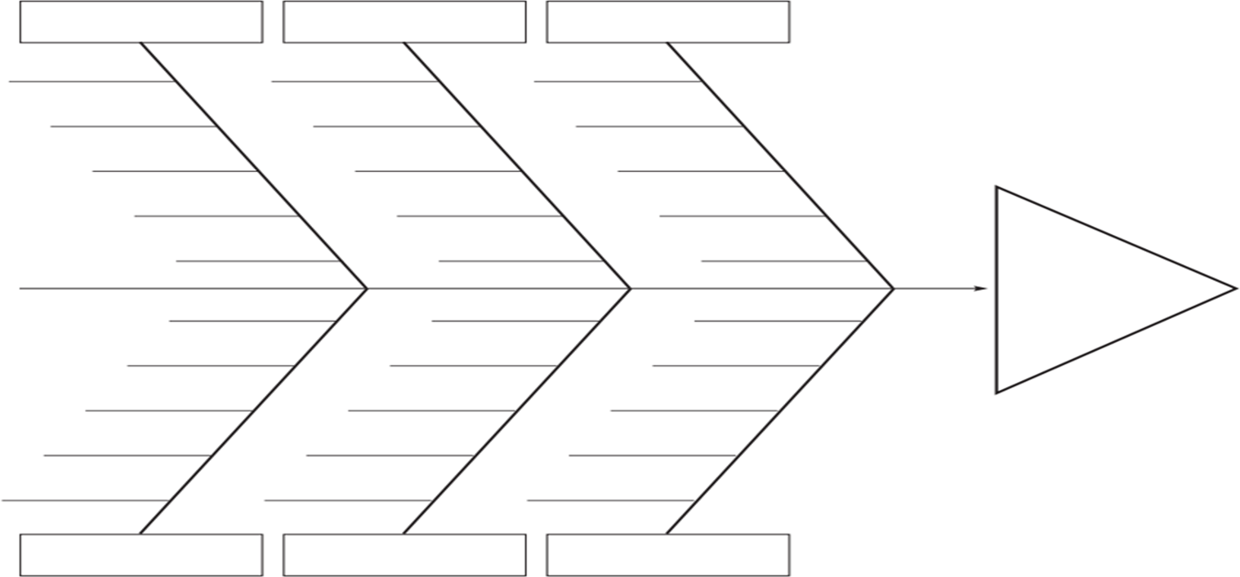
x

Learning Intentions
Methodology/Activities
Literacy/Numeracy
Homework
Resources Used/ICT
Assessment/Check In
Content of Lesson/Topic
Differentiation & Choice:

Lesson Plan: Thinking through Teaching and Learning Fishbone - Literacy
Date: ___________________ Year Group: ______________________

Content of Lesson |  | Sharing Learning Intentions |  | Literacy/Numeracy |  | Assessment /Check-in
Differentiation & Methodology | Activity to be used Differentiation/choices available How will the students demonstrate learning? Homework options |  |  |  |  | Resources used / Text, ICT
3 Worked well with this group |  |  | 2 Innovate - Change |  | 1 Not used with this group
Sample Lesson Plan: Thinking through Teaching and Learning - Fishbone - Literacy
Date: __________________ Year Group: ______________________

Content of Lesson |  | Learning Intentions |  | Methodology |  | Literacy / Numeracy & Links to Prior Learning
Differentiation & Choice |  | Assessment /Check-in |  | Resources used /Text, ICT |  | Homework & Pre-learning
Literacy & Numeracy Before Learning  Text Structure of Book/Anticipation Guides or strategy to encourage predicting or guessing/word splash & graphic tool e.g. 5WH. Pre-teach Key Words. Activate Prior Learning and link to what they know. |  |  | Literacy & Numeracy During Learning  Questioning skills / encourage mapping learning and teacher mapping- make the connections on the board with them. Teach it back, fix it up strategies, flow charts or any graphic tool that allows the student to  chunk the material and animate links in in learning. |  | Literacy & Numeracy After Learning  Summarising frames 321/54321/5WH/KWL. Mapping, Questioning. The more that the student processes the information through self and teacher and peer questioning the greater the learning. Question- Answer Relationship or Blooms Taxonomy.
3 Worked well with this group | 2 Innovate-Change | 1 Not used with this group
Sample Lesson Plan: Thinking through Teaching (How?) and Learning (What?) - Open narrative
Date: ___________________ Year: ___________________
Content/Topic  What Element of the Syllabus/  Specification? | Learning Intentions  Students will be able to … | Methodologies & Activities What I do to facilitate learning.  Differentiation - Choice | Assessment for & of Learning  Testing/Questioning/  Checking learning | Text, Resource, ICT
 |  |  |  | Literacy & Numeracy Supports & Targets
 |  |  |  | Assignments/ Homework/Pre- learning

Sample Lesson Plan: Thinking through Teaching (How?) and Learning (What?) - Chunked Narrative
Date: ________________________Year: ___________________
Content/Topic  What Element of the Syllabus/  Specification? | Learning Intentions  Students will be able to… | Methodologies & Activities What I do to facilitate learning.  Differentiation - Choice | Assessment for & of Learning  Testing/Questioning/  Checking learning | Text, Resource, ICT
 |  |  |  | Literacy & Numeracy Supports & Targets
 |  |  |  | Assignments/ Homework/Pre- learning

Sample Lesson Plan: Thinking through Teaching (How?) and Learning (What?)
Date:________________________Year:___________________
Learning Outcome
Methodologies/Activities
Learning Intentions
Students will be able to…

Teacher-led activities | Student-led activities

Assessment for Learning | Differentiation

Communication
Being Literate
Managing Myself
Staying Well
Managing Information and Thinking
Being Numerate
Being Creative
Working with Others

