Junior Cycle Home Economics
Unit of Learning
Year Group: _________ Duration of unit: _________
Department Planning
Learning Outcome | Choose the learning outcomes that students will experience in this unit using the drop-down menu.  Choose a Strand 1 Learning Outcome  Choose a Strand 2 Learning Outcome  Choose a Strand 3 Learning Outcome  Consider the learning outcomes across the strands and elements remembering the integrated nature of learning in Home Economics.  You may wish to underline / highlight the aspect(s) of the learning outcome that you will focus on in this unit, as the learning outcomes are for three years so you do not have to complete all of the learning outcome at a point in time.  Learning outcomes are agreed at department level.
Action Verb | Insert the action verbs from the learning outcomes that students will experience in this unit using the drop-down menu  Insert the Action Verb  Remember the action verbs are used to clarify the learning outcome, you may also wish to highlight these.
Key Learning | Given that learning outcomes are for three years, the key learning identifies the potential learning opportunities that could take place in this unit of learning and at this age and stage of development.  To identify the key learning, unpack the learning outcomes under knowledge and understanding, skills and values, while also considering the action verbs.  Key learning is agreed at department level.
Assessment | Assessment involves gathering evidence of what students could say, make, write or do, to demonstrate their learning.  Action verbs are central when considering the types of assessment, we want our students to experience.  Remember to align the assessment or check in points to specific learning outcome(s) in the unit. Assessment is aligned when it offers students a chance to demonstrate the intended learning from the learning outcome(s).  Assessment or check in points are agreed at department level.
Resources | It may be helpful to consider and share resources that would support learning throughout this unit.  Teachers also have autonomy to use the resources that they feel will best support student learning.

Individual Planning
Learning Intentions

A learning intention for a lesson or series of lessons is a statement that describes clearly what the students know, understand, and will be able to do as a result of learning and teaching activities.

Learning intentions help make clear, in student friendly language what students are learning. Discussing the learning intentions with students will ensure that student-friendly language is used and make the intended learning clear.
Learning intentions are always linked to one or more learning outcomes in the specification.

We are learning to….

Reflection
Individual  During and having completed the unit of learning, you may wish to consider questions such as;  - Did the selected learning outcomes integrate well together?  - What learning intentions did I share with the students in my class? Were these learning intentions suitable for my students?  - What learning experiences did I create with my students?  - Would I change any of the agreed assessment checks?  - How might we return to these learning outcomes in a future unit of learning? | Department

Home Economics | Unit of Learning:  Title here | Year:  Term:
Class Group: | Teacher:  SEN Link: | Duration:
L2LPs Subject Planning Template
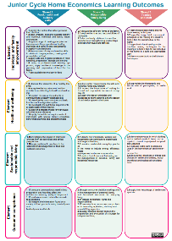
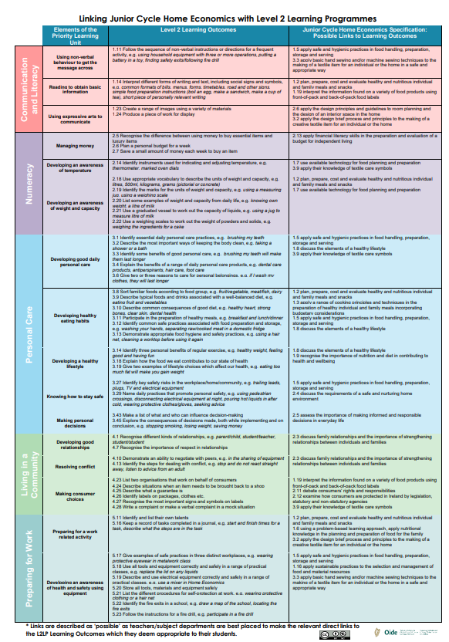
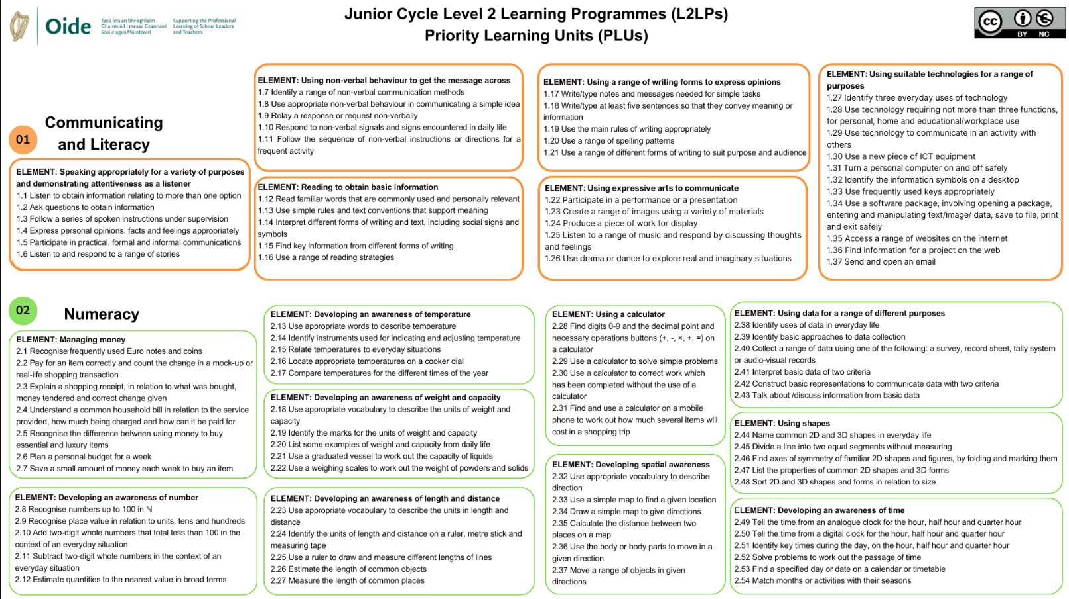
Home Economics

Linking Document
Home Economics
Learning
Outcomes
Poster

L2LP
Learning
Outcomes
Posters

Level 3 Unit of Learning - Learning Outcomes
Strand 1: Food, health and culinary skills  Choose a Strand 1 Learning Outcome | Choose a Strand 1 Learning Outcome | Choose a Strand 1 Learning Outcome | Choose a Strand 1 Learning Outcome
Strand 2: Responsible  family living  Choose a Strand 2 Learning Outcome | Choose a Strand 2 Learning Outcome | Choose a Strand 2 Learning Outcome | Choose a Strand 2 Learning Outcome
Strand 3: Textiles and craft  Choose a Strand 3 Learning Outcome | Choose a Strand 3 Learning Outcome | Choose a Strand 3 Learning Outcome | Choose a Strand 3 Learning Outcome

L2LPs - Learning Outcomes
Communication & Literacy  Choose a PLU 1 Learning Outcome | Choose a PLU 1 Learning Outcome | Choose a PLU 1 Learning Outcome | Choose a PLU 1 Learning Outcome
Numeracy  Choose a PLU 2 Learning Outcome | Choose a PLU 2 Learning Outcome | Choose a PLU 2 Learning Outcome | Choose a PLU 2 Learning Outcome
Personal care  Choose a PLU 3 Learning Outcome | Choose a PLU 3 Learning Outcome | Choose a PLU 3 Learning Outcome | Choose a PLU 3 Learning Outcome
Living in a community  Choose a PLU 4 Learning Outcome | Choose a PLU 4 Learning Outcome | Choose a PLU 4 Learning Outcome | Choose a PLU 4 Learning Outcome
Preparing for work  Choose a PLU 5 Learning Outcome | Choose a PLU 5 Learning Outcome | Choose a PLU 5 Learning Outcome | Choose a PLU 5 Learning Outcome

Activity Description
in the Subject Class

Assessment Opportunities
Success Criteria
Evidence of Learning |  | Location of Evidence of Learning
- Observations  - Feedback/ Next steps | - X  - X

Signed ______________________________ Date: _________________

