NQT Cluster Meeting 2 Document
Reflective Practice Framework: Gibbs’ Reflective Cycle

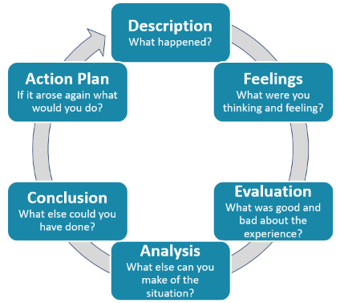

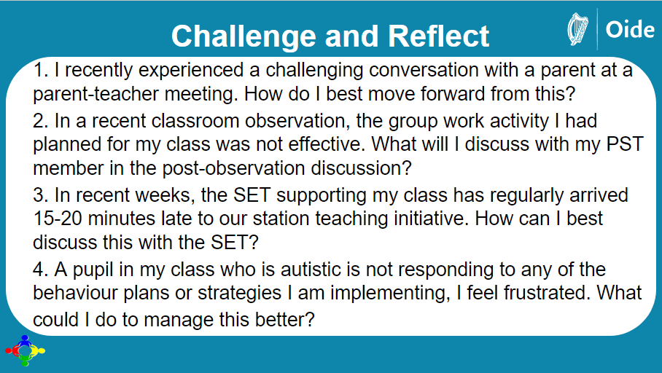
Classroom Management – Suggestions
Please see the full Classroom Management Toolkit on our website.
Classroom Management Area | Scenarios… | Suggestions…
Managing transitions between lessons | - What strategies could be used to settle the children after break?  - Any suggestions for managing the class when we go to the hall/yard/field for PE?  - Other ideas for transitions between lessons. | Use this time as an opportunity to revise material already covered in class e.g., songs, poems, tables, spellings, drama ideas (See ‘100+ ideas for Drama’).
Managing ‘noise’ levels | - Managing the noise level in the classroom can be difficult. I find myself raising my voice quite a lot. What should I do? How do I regain the children’s attention?  - When the children are working in groups, they are constantly asking me what to do. How can I remedy this situation? | Teach the pupils the appropriate voice levels for the various activities to be conducted in the classroom.
Classroom organisation | - How can I get on top of corrections – it can be overwhelming?  - Taking down homework seems to take forever! How can I reduce the time it takes?  - What should effective classroom rules look like? | On the spot corrections are most effective so it is best to circulate and correct as pupils undertake an activity.
Managing individual needs | - Can you advise me what to do to support self-directed learning?  - What could I do to engage children who swing on their chairs, play with pencil cases, root in their bags, etc.?  - I am worried about children in my class who are in need of lots of individual attention. What can I do? | Consult with the SET as soon as you can. Observe and make notes on the times when support is most needed. These notes should be evidence based.

