Droichead Planning Toolkit - Post-primary
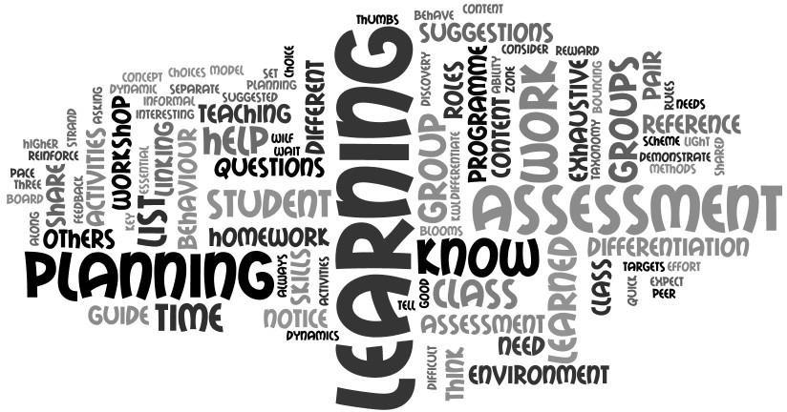
The following templates are samples that could be used and/or adapted to facilitate the development of class planning documentation. They allow for targets that have been identified at a national level e.g., literacy and numeracy, at a local level within the school/subject department and at an individual class level depending on the needs of the group. These templates also build on the content of the Induction Workshops which are open to all NQTs to support their professional learning.
These templates have been designed in consultation with the Droichead Induction Division and links to other Oide Divisions are included where appropriate. These templates can and should be adapted to suit individual subjects, schools’ needs and planning formats.
Class Profile for Teaching and Learning | This is a brief overview of the class group you are teaching. It includes key information to assist in planning to meet the needs of the group. It is completed at the start of the year and adapted and improved throughout the year. The seating plan can also be used to observe targets or to map student behaviour or engagement.
Recording of Student  Progress | When recording student progress and attainment it is essential that different forms of assessment are included. This could take the form of identifying a skill such as questioning or co-operation as a target for a class, and observing and recording what you notice at different times during the week.
Planning for Good  Behaviour and Strengths | Setting targets for your class, such as punctuality, co-operation, spelling targets or using a particular strategy, can be used to chart students’ success. This will encourage the active noticing and validating of the behaviour/learning that you require in class. There are sample targets in the QRG (Quick Reference Guide) on the last two pages of the document.
Thinking Through Teaching and Learning - Year Plan | Using the Syllabus to plan the content to be covered in the full year, taking into consideration the targets and decisions that have been identified at a school and department level. This can and will change during the year depending on factors that have impacted on learning within the class. Three or two sheets can be used to break the syllabus over three or two years.

Half-Term Plan | The content you will teach starts to be filtered through the learning needs of the class as identified through the information systems in the school. The class profile and the factors affecting areas such as differentiation, inclusion, literacy, and assessment needs to be included in the decisions regarding the content and the methodologies/ activities chosen. You will expand the detail if you use the weekly plan for the content you cover with the group.
Weekly Plan | Thinking through the content for the week and using this template will allow you to go into more detail about the methodologies, differentiation, inclusion factors and the resources etc. that will be needed for the group. As with all templates, they can be changed to suit the needs of the class and the teacher.
Lesson Plan | When teaching a topic that needs thorough targeted planning, or working with a class that requires considerable preparation and planning, this helps guide the teacher in thinking through all aspects that need to be considered for that particular class. The use of a Fishbone graphic organiser allows you to gather a lot of information on that topic and class. The reflection section is important to bring new learning forward with the group. Several blank forms can be used over time to track your planning with a group.
Quick Reference Guide | This list is not exhaustive. It serves to remind you of the methodologies and skills that you have acquired during Initial Teacher Education (ITE) and developed and extended during induction and into your teaching career. This will give teachers a reminder as they are planning and thinking about factors such as inclusion, differentiation, and literacy for example.

Class Profile for Teaching and Learning
Subject |  |  | Programme of Study |  |  |  |  | Year of Cycle |  |  |  |  | Homework Routine
Inclusion & SEN Consideration within this Group |  |  |  |  | Groupings Used/Taught |  |  |  |  |  | Behavioural Targets/Strengths
 |  |  |  |  |  | Whiteboard
Class Profile for Teaching and Learning

Subject |  |  | Programme of Study |  |  |  |  | Year of Cycle |  |  |  |  | Homework Routine
Inclusion & SEN Consideration within this Group |  |  |  |  | Groupings Used/Taught |  |  |  |  |  | Behavioural Targets/Strengths

Whiteboard

Class Profile for Teaching and Learning

Programme of Study | Year of Cycle | Homework Routine
Inclusion & SEN Consideration within this Group | Groupings Used/Taught | Behavioural Targets/Strengths

Whiteboard

Recording of Student Progress
(can be used monthly or as a termly record of areas identified by teacher)
Name | Observations/AfL | Classwork  Strengths | Social Skills  Targets | Assignments | Other | Name | Observations/AfL | Classwork  Strengths | Social Skills  Targets | Assignments | Other

Planning for Good Behaviour and Social Skills — Noticing Effort
Student name | Notable good behaviour/skills/strengths/work/effort | Student name | Notable good behaviour/skills/strengths/work/effort
1 |  | 16
2 |  | 17
3 |  | 18
4 |  | 19
5 |  | 20
6 |  | 21
7 |  | 22
8 |  | 23
9 |  | 24
10 |  | 25
11 |  | 26
12 |  | 27
13 |  | 28
14 |  | 29
15 |  | 30

Term Plan

Subject:
Term:
Year Group:

Learning Outcomes | Key Learning Points | Activities | Assessment | Reflection

Thinking through Teaching (How?) and Learning (What?) Half-Term Plan
Date: _________________ Year Group: ___________________
Week | Content/Topic  What Element of the Syllabus or Specification? | Learning Intentions  Differentiation  Students will be able to… | Methodologies  Activities  What I do to facilitate learning | Assessment for (AfL) & of (AoL) Learning  Testing/ Questioning/ Checking Learning | Text Resource ICT | Literacy & Numeracy Supports | Assignments/Homework  Pre-Learning for Next Class
1
2
3

Thinking through Teaching (How?) and Learning (What?) Half-Term Plan
Date: ________________ Year Group: _________________
Week | Content/Topic  What element of the Syllabus or Specification? | Learning Intentions  Differentiation  Students will be able to … | Methodologies  Activities  What I do to facilitate learning. | Assessment for (AfL) & of (AoL) Learning  Testing/ Questioning / Checking learning | Text Resource ICT | Literacy & Numeracy Supports | Assignments /Homework  Pre-learning for next class
4
5
6

Department Planning
Unit Name |  |  |  | Year Group
Department Unit of Learning |  |  |  | In Your Classroom
Learning Outcomes (From Specifications) |  |  | Learning Intentions
Key Concepts (knowledge, understanding, skill, value) |  |  | Success Criteria
Possible Learning Experiences |  |  | Other Learning Experiences
Evaluation of Student Learning |  |  | Teacher Reflection/  Notes

Thinking through Teaching (How?) and Learning (What?) Weekly Plan Version 1
Date: ___________________________ Year Group: _________________________
Day | Content/Topic  What Element of the syllabus or specification? | Learning Intentions  Differentiation  Students will be able to… | Methodologies  Activities  What I do to facilitate learning | Assessment for (AfL) & of (AoL) Learning  Testing/Questioning/ Checking learning | Text  Resource  ICT | Literacy & Numeracy Supports | Assignments/Homework  Pre-learning for next class
Mon
Tues
Wed
Thurs
Fri

Thinking through Teaching (How?) and Learning (What?) Weekly Plan Version 1
Date: ____________________________ Year Group: _________________________

Day | Content/Topic  What element of the syllabus or specification? | Learning Intentions  Differentiation  Students will be able to … | Methodologies  Activities  What I do to facilitate learning. | Assessment for (AfL) & of (AoL) Learning  Testing/Questioning/ Checking learning | Text  Resource  ICT | Literacy & Numeracy Supports | Assignments /Homework  Pre-learning for next class
Double
Single
Single
Single

Weekly Plan Version 3  Date: | Content/Syllabus or Specification |  |  |  | Links to Prior Knowledge
 | Inclusion and Differentiation Factors for this Learning Group: |  |  |  | Learning Intentions “the student will be able to...”
Consider: Content/Pre-teaching/Methodology/Literacy/Numeracy/Resources/Behavioural Targets/Assessment & Questioning/ Differentiation
Mon |  | Tues |  | Wed |  | Thurs |  | Fri
Homework- Written, Reflective, Research ICT, Thinking Forward, Keyword Investigation, Image Based, Mapping or Thinking Through What We Learned.
Literacy and Numeracy Before Learning  Text structure of book/anticipation guides or strategy to encourage predicting or guessing/word splash & learning frame e.g., 5WH  Pre-teach keywords. Activate prior learning and link to what they know. |  |  | Literacy and Numeracy During Learning  Questioning skills/encourage mapping learning and teacher mapping- make the connections on the board with them. Teach it back, fix it up strategies, flow charts or any graphic tool that allows the student to chunk the material and animate links in learning. |  |  |  | Literacy and Numeracy After Learning  Summarising frames 321,54321,5WH, KWL. Mapping, questioning. The more that the student processes the information through self and teacher and peer questioning the greater the learning. QAR or Bloom question stems.

 |  | Day Plan | M T W T F | Date
Year | Subject | Core Content and Activities Planned | Notes and Follow-Up

Thinking through Teaching (How?) and Learning (What?) - Lesson Plan V1 - Fishbone
Date: ___________________ Year Group: ____________________

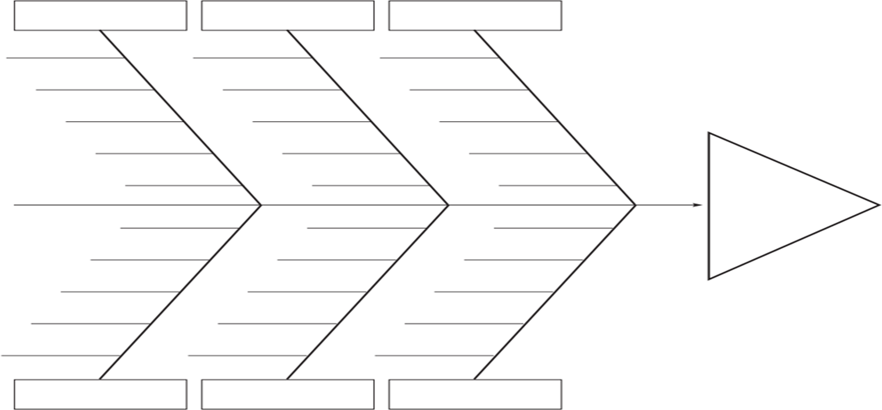
x

Learning Intentions
Methodology/Activities
Literacy/Numeracy
Homework
Resources Used/ICT
Assessment/Check In
Content of Lesson/Topic
Differentiation & Choice:

Thinking through Teaching and Learning - Lesson Plan V2 - Fishbone - Literacy
Date: ___________________ Year Group: ______________________

Content of Lesson |  | Sharing Learning Intentions |  | Literacy/Numeracy |  | Assessment /Check-in
Differentiation & Methodology | Activity to be used Differentiation/choices available How will the students demonstrate learning? Homework options |  |  |  |  | Resources used / Text, ICT
3 Worked well with this group |  |  | 2 Innovate - Change |  | 1 Not used with this group
Thinking through Teaching and Learning - Lesson Plan V2 - Fishbone - Literacy
Date: __________________ Year Group: ______________________

Content of Lesson |  | Learning Intentions |  | Methodology |  | Literacy / Numeracy & Links to Prior Learning
Differentiation & Choice |  | Assessment /Check-in |  | Resources used /Text, ICT |  | Homework & Pre-learning
Literacy & Numeracy Before Learning  Text Structure of Book/Anticipation Guides or strategy to encourage predicting or guessing/word splash & graphic tool e.g. 5WH. Pre-teach Key Words. Activate Prior Learning and link to what they know. |  |  | Literacy & Numeracy During Learning  Questioning skills / encourage mapping learning and teacher mapping- make the connections on the board with them. Teach it back, fix it up strategies, flow charts or any graphic tool that allows the student to  chunk the material and animate links in in learning. |  | Literacy & Numeracy After Learning  Summarising frames 321/54321/5WH/KWL. Mapping, Questioning. The more that the student processes the information through self and teacher and peer questioning the greater the learning. Question- Answer Relationship or Blooms Taxonomy.
3 Worked well with this group |  |  | 2 Innovate-Change |  | 1 Not used with this group
Thinking through Teaching (How?) and Learning (What?) - Lesson Plan - V4 - Open narrative
Date: ___________________ Year:___________________
Content/Topic  What element of the Syllabus/  Specification? | Learning Intentions  Students will be able to … | Methodologies & Activities What I do to facilitate learning.  Differentiation - Choice | Assessment for & of Learning  Testing/Questioning/  Checking learning | Text, Resource, ICT
 |  |  |  | Literacy & Numeracy Supports & Targets
 |  |  |  | Assignments/ Homework/Pre- learning

Thinking through Teaching (How?) and Learning (What?) - Lesson Plan - V5 - Chunked Narrative
Date: ________________________Year: ___________________
Content/Topic  What element of the Syllabus/  Specification? | Learning Intentions  Students will be able to… | Methodologies & Activities What I do to facilitate learning.  Differentiation - Choice | Assessment for & of Learning  Testing/Questioning/  Checking learning | Text, Resource, ICT
 |  |  |  | Literacy & Numeracy Supports & Targets
 |  |  |  | Assignments/ Homework/Pre- learning

Thinking through Teaching (How?) and Learning (What?) - Lesson Plan - V6 - Junior Cycle
Date:________________________Year:___________________
Learning Outcome
Methodologies/Activities
Learning Intentions
Students will be able to…

Teacher-led activities | Student-led activities

Assessment for Learning | Differentiation

Communication
Being Literate
Managing Myself
Staying Well
Managing Information and Thinking
Being Numerate
Being Creative
Working with Others

Keywords:
Reflection: What worked well? What needs development? Etc.
Outline of Whiteboard 1:

Outline of Whiteboard 2:

Professional Learning Materials and Information on Post-primary Subjects
Please click on the images to access subject specific professional learning materials.
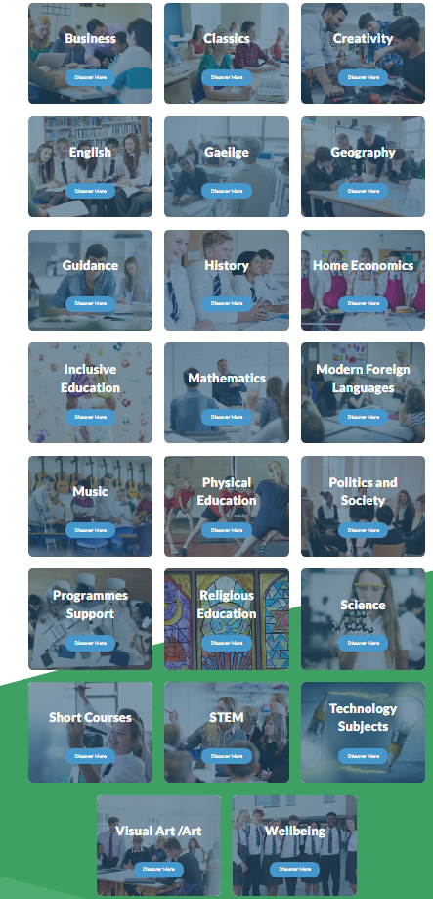

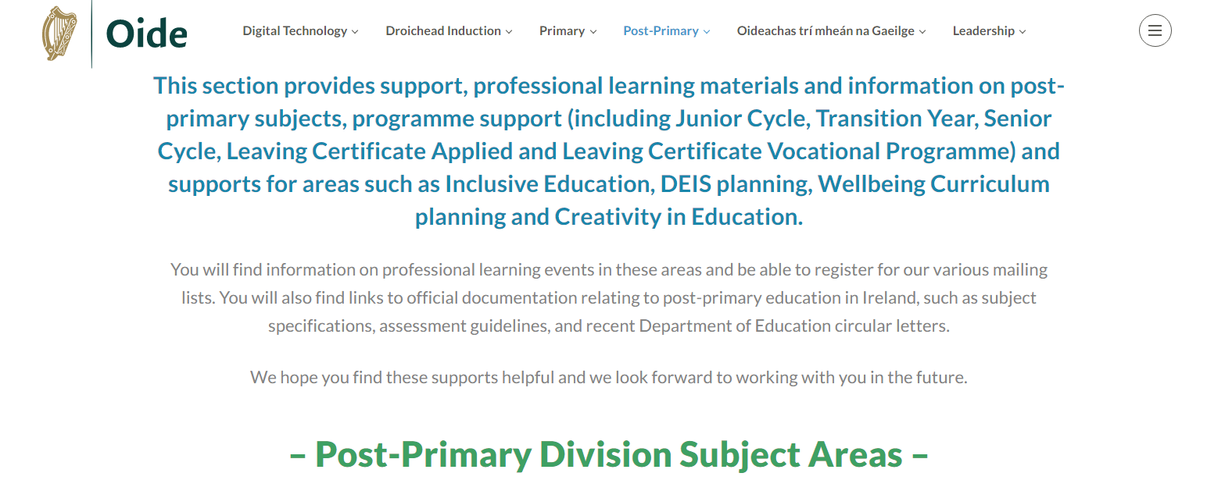

Assessment  AfL/AoL | Quick Reference Guide  This list is not exhaustive. | Behaviour
WALT- We Are Learning To ...  WILF - What I am Looking For...  KWL - Know/Want to Know/Learn.  Observations.  Concept Mapping.  Portfolio Work.  Questions - Bloom's Taxonomy.  Think Time for All- Hands Down/ Mini boards/ Distributed Answering.  Answer Bouncing or Building Think Pair Share.  Self-Assessment- Traffic Light, Scales, Thumbs-Up.  Checklists for Correction.  Marking Scheme.  Three Strand Feedback- Sandwich.  Peer Assessment.  Correcting Sample Answers. | Differentiation  Content What you want them to know / key words/ pre teach.  Activities The activities you use to help them make sense of what they are learning.  Resources Books/ worksheets/ ICT.  Product How they demonstrate that they have learned. Board work/ Questions/ Homework / AfL.  Environment Social and emotional aspects/ Feelings/ Group dynamics/ Relationships/ Physical environment.  Teaching Strategies Approaches used by the teacher, board work, group work, discovery learning, pair share.  Pace The rate of delivery and how I move the class along. The routine of class is essential here.  Assistance Planning how you will assist when it is needed. Linking this to social skills development and to cooperation and learning. Hurdle help, wait time. Linking questioning skills and fix it up strategies to assistance. Asking for help is expected and wanted.  Testing The methods you use to test what they have learned? Assessment method listed overleaf. This is just a suggested list, others such as table quiz, shared assessment, group tests and many others are possible. The more interesting and dynamic the assessment the higher the learning on Bloom’s taxonomy will be.  Class Groups How I organise groups in the class for different sessions. Changing the criteria and roles in the group. Teaching them the different roles in groups. Encouraging cooperative learning.  Homework Very important and needs to be differentiated. Consider time, ability, choice, thinking through to see what might be difficult. Not always writing, varied activities. | ‘Our Class Rules’- remind, reinforce, and reward.  Set targets for students and celebrate when achieved.  Name what you need them to do and thank students when they do.  Differentiate response to students.  Notice when they behave well- formal and informal.  They need to know that you are on their side.  Notice effort often.  Expect a lot and tell them when they get there.  Share good behaviour with parents.  Give them choices.  Encouragement procedures.  Model required behaviour.  Teach them the skill you want to see.  Stay in the Learning Zone.  Use "I'.  Separate the behaviour from the student.

Inclusive Practice
Social/ Environmental  - Friendships – Break time.  - Food breaks, eating in groups.  - Differentiated scaffolding methods and support.  - Cultural sensitivity with social norms and behaviours.  - Mobility - Access.  - Signposting lessons.  - Visual Cue/Signs. | Curriculum/ Assessment  - Awareness of hidden curriculum.  - Varied methods of assessment: Self, conferencing, portfolio, mapping, questioning, observations, teacher tests, standardised testing.  - Clarity with expectations and cultural and social sensitivity with the content and representation in curriculum. | Language and EAL  - Name usage and pronunciation.  - EAL profile and learning needs.  - Encourage some use of first language.  - Expressive and receptive language issues and SEN.  - Processing speeds and activities/assignments.  - Check understanding.  - Common tasks/instructions/ routines translated—numbered. | Activity and Grouping  - Types of groups.  - Mix in groups, language, ability, activity etc.  - Roles and expectations in  groups.  - Buddy - student mentoring.  - Differentiated for ability and learning style.  - Use of learning frames and graphic organisers to focus on key vocabulary development.

Some Methodologies

Pair work / Group work | Modelled/Guided reading | Brainstorming -Thought showers | Interview | Cooperative learning | Project work | Scaling | Artwork
Collaborative Groups | Discovery learning - Investigative | Concept mapping | Any graphic organiser | Role Play | ICT usage in class | Demonstrations | Storyboarding
Aural Comprehension | Specific Software programme | Discussion groups | Walking debate | Creative Writing | Debate – Guest Speaker-Oral Evidence | Jigsaw groups | Station Teaching
Reading Tasks | Pictures and Imagery works | Written activities | Spot Demonstrations | Paired Reading | Annotated Diagrams | Teach it back | Quiet work time
Some Lesson Starters and Plenary Activities
Odd one out - list three things, two connected and one not. In groups or individually.
A-Z in 3 - think of a word for each letter connected to topic. Groups or individual.
Word splash and learning frame e.g., 3,2,1
Words to pictures - convert a section of text to simple images.
Scaling activity for understanding.
20 questions - ask as many questions as possible on yesterday’s topic, group or individual.
True or false - anticipation guide, mind mapping or graphic organiser.
Feelings check on learning.

Learning a Skill or a Strategy | Emotional and Social Skills to Notice and Target
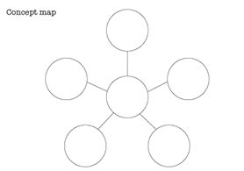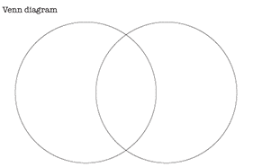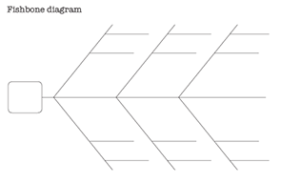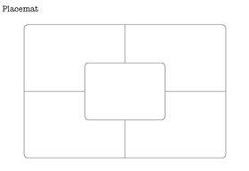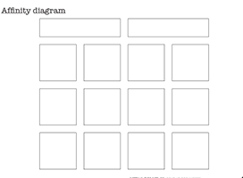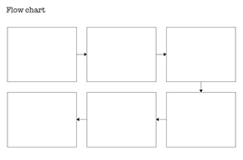
Sourced from:https://getting-it-together.moadoph.gov.au/teacher-guide/graphic-organisers.html

Organised
Sharing
Cooperative
Persistent
Feelings words
Thoughtful and kind
Optimistic
Questioning
Listening
Discussion
Asking for help
Brave
Motivated
Turn taking
Encouraging others
Voice volume
On task
Manners

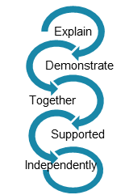

Teacher Reflection Document

Weekly Reflection  You may wish to reflect on one or two of the following prompts or you may prefer to use your own.  -What worked particularly well in  my classroom this week?  -What was the most challenging moment in my teaching?  - If there was one thing, I could do to improve the pupils’ learning what would that be?  -What change/s could I make in my short-term planning, based on my experience in the classroom?  -Was I clear about what learning I wanted the students to achieve in each lesson?  -How effective were my assessment methods in helping me identify what the students had learned?  -How did I cater for the different student’s learning needs and/or styles in my class? Consider methodologies and differentiation.  -Think about one student’s progress this week? Consider their learning/behaviour/ social and emotional area. How effective were the strategies I used to support this student?  -How effectively did I integrate Literacy and Numeracy learning in my lessons? |  | Week 1:
 |  | Week 2:
 |  | Week 3:

