Long-Term Planning – Prompts for NQTs
Long-term planning outlines educational goals, curriculum and teaching methods, for an extended period. These plans, devised at school level, are informed by best practice to deliver the curriculum through high-quality teaching and targeted academic support. Plans are crucial in delivering a consistent and effective educational experience which ensures that all necessary topics are covered while also aligning with educational standards and goals.
“The teacher: selects and uses planning, preparation and assessment practices that progress students’ learning... [This] includes preparation for the differentiation of learning intentions and learning activities, including personalised learning opportunities, and is informed by meaningful analysis of and use of data as well as teachers’ professional judgement and decision-making” (LAOS, 2022, p30).

At school level please refer to subject department plans.

For guidance on best practice, please refer to Looking at our School (2022).
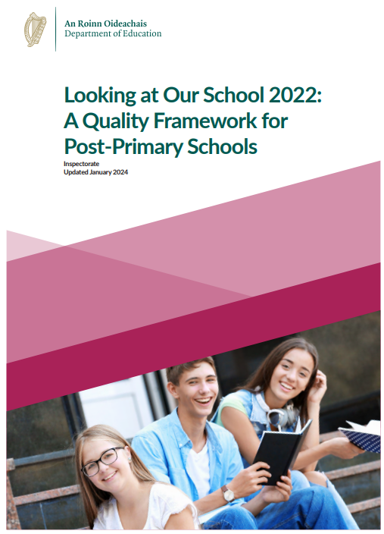

For subject specific guidance, refer to the NCCA (National Council for Curriculum and Assessment).
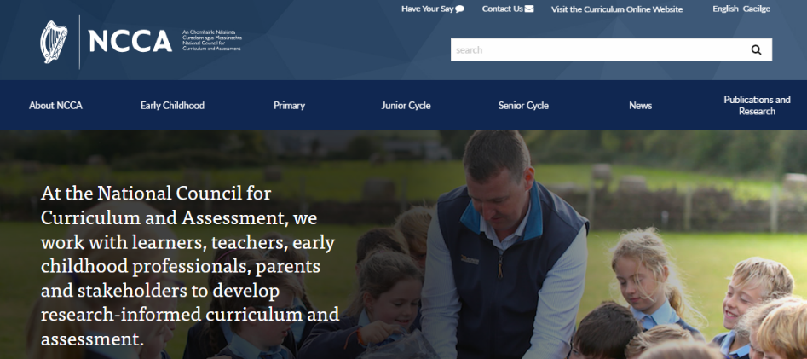

For support dedicated to post-primary teachers and schools, refer to: Oide.ie

For guidance on Literacy, Numeracy and Digital Literacy, refer to: www.gov.ie

