Geography

Professional Learning Booklet

2024-2025

Table of Contents

Structure of the Geography Specification for Junior Cycle 2

Junior Cycle Geography Learning Outcomes 3

Strand 1: Exploring the physical world 3

Strand 2: Exploring how we interact with the physical world 3

Strand 3: Exploring people, place and change 3

Identifying themes 4

Planning and Preparation for the Outdoor Classroom 5

Inclusive Practice 6

Sample Vocabulary Boards & Cards 6

Choice Boards 6

Assistive Technology 7

EAL Resources 8

Google version of the EAL Sheet 8

Microsoft version of the EAL Sheet 8

Teacher Activity: Outdoor Classroom Survey 9

Teacher Activity: Designing your Outdoor Classroom Learner Experience 12

Survey 123 – Virtual Tour 14

Getting started with Survey 123 – Teach with GIS 14

Senior Cycle Documents 15

Draft Transition Year Programme Statement 15

Key Competencies in Senior Cycle (draft) 15

Reflecting on the Outdoor Classroom & Transition Year Geography 16

Transition Year Module Template 17

Teacher Activity: Planning a TY Module 20

Transition Year Resources 21

Geography Resources 23

Reflecting on the Day 24

References 25

Notes 26

# Structure of the Geography Specification for Junior Cycle

A close up of a logo

Description generated with high confidence

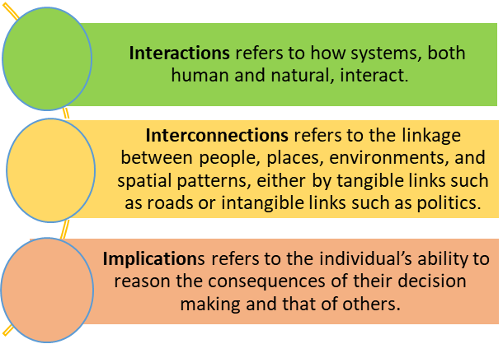

# Junior Cycle Geography Learning Outcomes

|  |  |
| --- | --- |
| **Elements** | Strand 1: Exploring the physical world |
| * Processes, patterns, systems and scale * Geographical Skills * Sustainability | **Students should be able to:**  1.1 describe the formation and global distribution of volcanoes, earthquakes, and fold mountains in the context of plate tectonics and structure of the Earth  1.2 distinguish between different categories of rock type, referring to  composition and formation  1.3 analyse the processes and effects of weathering and mass movement on our landscape  1.4 assess a soil type in a local area in relation to composition and vegetation  1.5 explain how the processes of erosion, deposition and transportation shape our fluvial, marine, and glacial landscapes  1.6 classify global climates, and analyse the factors that influence the climate in Ireland  1.7 investigate the formation and behaviour of a significant weather event  1.8 gather, record, and interpret weather data  1.9 differentiate between the types of energy resources produced by the physical world  1.10 investigate a range of physical processes active in a chosen location and the connections between them |
| **Elements** | Strand 2: Exploring how we interact with the physical world |
| * Processes, patterns, systems and scale * Geographical Skills * Sustainability | **Students should be able to:**  2.1 describe the economic and social impacts of how we interact with the occurrence of volcanoes, earthquakes, and fold mountains  2.2 evaluate the environmental, economic, and social consequences of rock exploitation and energy resources  2.3 identify how the physical landscape influences the development of primary activities  2.4 assess the exploitation of water, fish stocks, forestry, and soil as natural resources  2.5 describe a local secondary activity in relation to its function and the factors that influence its location  2.6 examine the causes and implications of climate change  2.7 investigate examples of how people interact with and manage surface processes  2.8 investigate how people respond to a natural disaster  2.9 assess the interrelationships between the physical world, tourism and transport. |
| **Elements** | Strand 3: Exploring people, place and change |
| * Processes, patterns, systems and scale * Geographical Skills * Sustainability | **Students should be able to:**  3.1 use the demographic transition model to explain populations’ characteristics and how populations change  3.2 investigate the causes and consequences of migration  3.3 examine population change in Ireland and in a developing country  3.4 consider the factors affecting the location and origin of rural and urban settlement in Ireland  3.5 examine the causes and effects of urban change in an Irish town or city  3.6 identify global patterns of economic development  3.7 compare life chances for a young person in relation to gender equality, health care, employment, and education opportunities in a developed and a developing country  3.8 evaluate the role of development assistance in human development  3.9 synthesise learning of population, settlement and human  development within the process of globalization |

# A cartoon character with a question mark Description automatically generatedIdentifying themes

**As you watch the video, what evidence did you see**

**of each of these themes?**

|  |
| --- |
| **Inclusive Practice** |
| **Evidence:** |
| **Geographical Skills** |
| **Evidence:** |
| **Making Connections** |
| **Evidence:** |

# Planning and Preparation for the Outdoor Classroom

The graphic below provides a possible guide to **collaborative planning for the Outdoor Classroom**with your colleagues in your geography department.​​

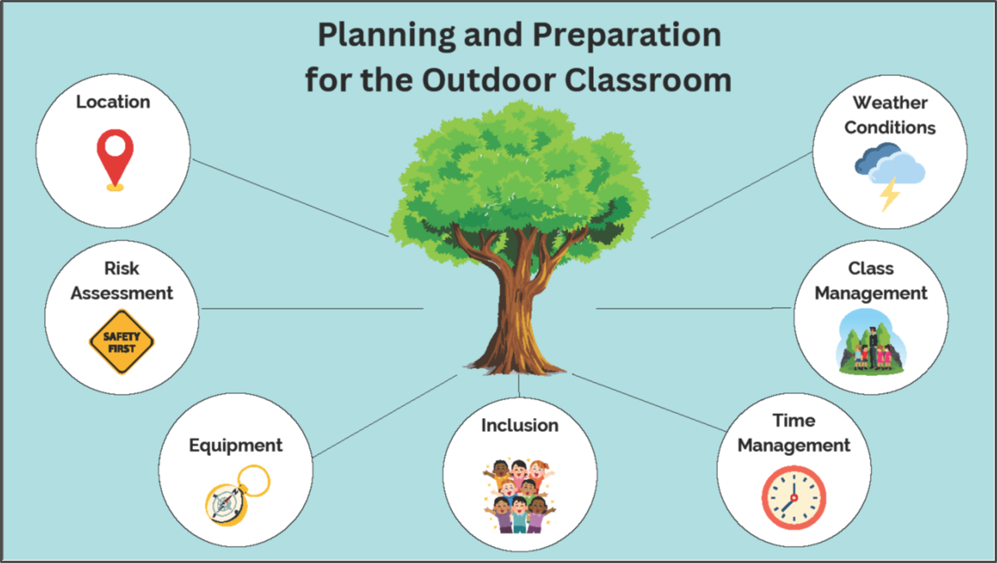

* ​**Location,** it is good to begin by looking at the local geography available to you that piques the interest of your students.​ Chooses a safe and accessible location.
* It is very important to always stay safe so a **risk assessment** is fundamental to ensure that safety is effectively managed.
* Decide on **equipment** needed and practice using it with your students prior to the trip. Equipment can be borrowed from the school science lab. Also, it is worth considering making some of your own equipment.
* When planning and preparing for the Outdoor Classroom it is important to consider **equitable & inclusive access to learning** so that all students can participate.
* **Time** is one of the most frequently mentioned barriers to outdoor learning, the common perception is that it takes more **time** to plan so it would be advisable to pick the most convenient location as already mentioned, prepare activities and run through how the class will take place so that students will be ready to start as soon as they get to the location.
* **Class Management,** the key to getting students outdoors successfully is preparation. One way to prepare students is to explain to them exactly what is going to happen once they go outside. Express your rules and establish clear boundaries ahead. Possibly use colour coded groups for inclusion as students often remember their group colour.
* ​Always check the **weather forecast** for weather conditions. If visiting the coast always check the **tides** as a safety precaution.

​

# Inclusive Practice

## Sample Vocabulary Boards & Cards

Vocabulary Boards also known as Communication boards ae useful for students with additional needs because they use symbols rather than words. They can help reduce communication barriers for students with by providing visual aids, like pictures and symbols, which are often easier for them to understand, and use compared to text.

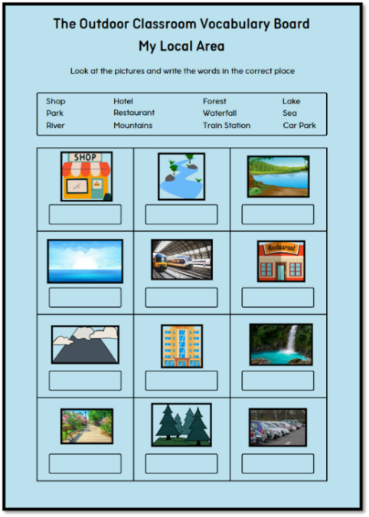 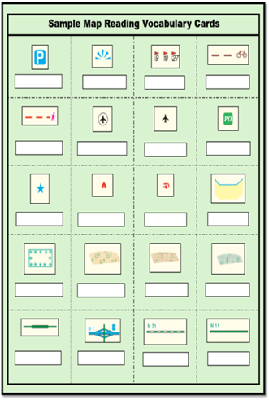C

## Choice Boards

Choice boards provide students with the opportunity to make their own choices, which increases intrinsic motivation and therefore increases meaningful learning. 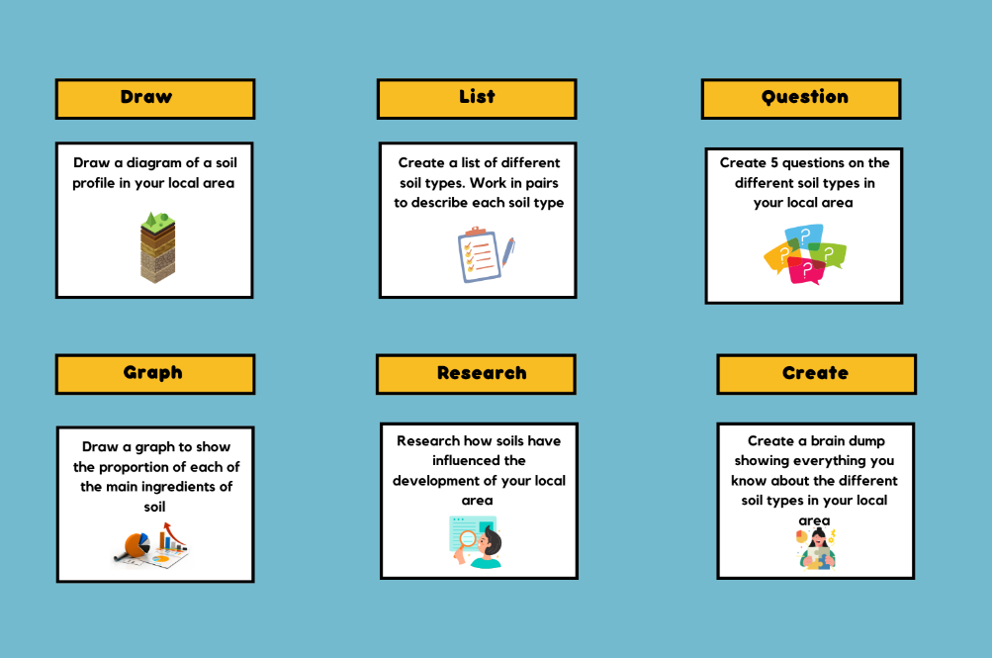

# Assistive Technology

Technology has changed the face of education and for many students with additional needs, it has levelled up the playing field and enabled them to realise their true potential. Assistive Technology is the term used for specialist equipment or computer software, which help and enable students to reach their potential.

# EAL Resources

This Geography Translators are digital supports for the teaching of EAL in the Geography classroom.

Click on the images below to access our Geography Translators.

## Google version of the EAL Sheet

](https://docs.google.com/spreadsheets/d/1xu0lr63NngqTwyFOPQZjrwUI8VvQ2wEe4XYBwvjfFLU/edit#gid=0)

<https://docs.google.com/spreadsheets/d/1xu0lr63NngqTwyFOPQZjrwUI8VvQ2wEe4XYBwvjfFLU/edit#gid=0>

## Microsoft version of the EAL Sheet

[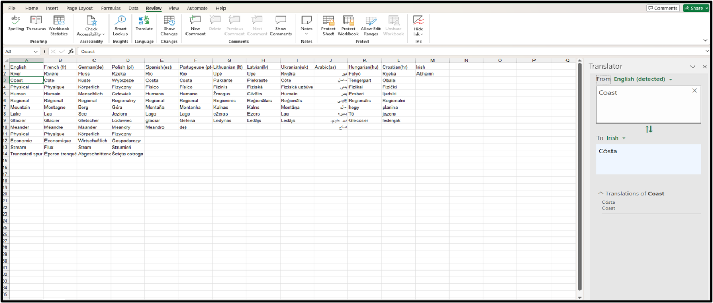](https://jctie.sharepoint.com/:x:/s/ClusterWorkshops/EaxDPPmM9NtLphmVpcu8F6QB35a0HOxg6CpISzuuqQC-JA?rtime=dNve_tp43Eg)

<https://jctie.sharepoint.com/:x:/s/ClusterWorkshops/EaxDPPmM9NtLphmVpcu8F6QB35a0HOxg6CpISzuuqQC-JA?rtime=dNve_tp43Eg>

# Teacher Activity: Outdoor Classroom Survey

Using **Survey 123 (or printed worksheet)**

* Investigate aspects of **Local Geography** for the **Outdoor Classroom.**

Click on the image of Survey 123 below to open it online.

**[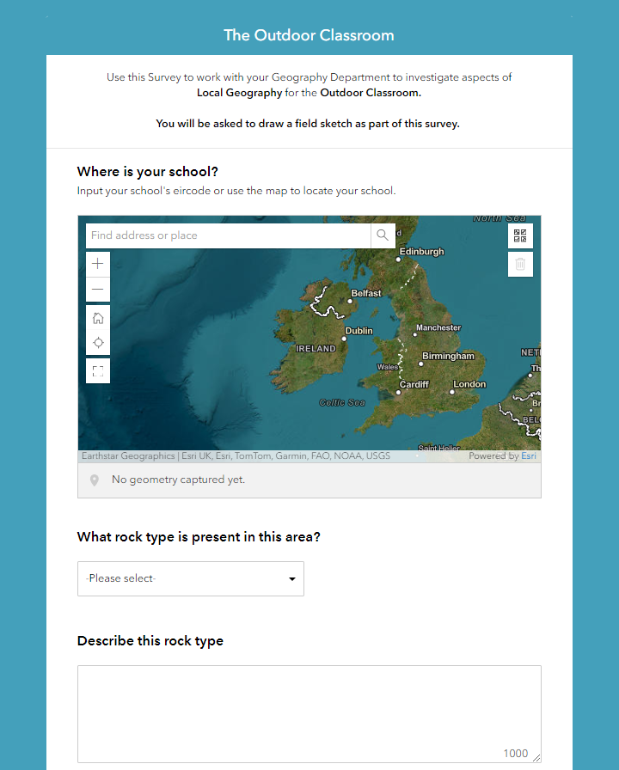](https://survey123.arcgis.com/share/721046411b554db8b92a6e73a35e30d4)**

[**https://arcg.is/11LTfC1**](https://arcg.is/11LTfC1)

|  |
| --- |
| **Use this Survey to work with your Geography Department to investigate aspects of Local Geography for the Outdoor Classroom** |
| Where is your school? |
| What rock type is present in this area? |
| Describe this rock type. |
| What soil type is present in this area? |
| Describe this soil type. |
| Is there a water source in the area, name it? |
| What Physical Landforms can you identify? |
| Take a photo of these Landforms. |
| What processes can you see evidence of that created these landforms? |
| Take a photo showing evidence of these processes. |
| What types of land use can you identify in this area?  Residential Industrial Agricultural Transport Commercial  Health Education Recreation Services Other |
| What are the Primary Economic Activities in this area?  Fishing Forestry Mining Agriculture (pastoral) Agriculture(dairy) Agriculture(mixed) |
| What evidence can you see to show that there are Primary Economic Activities in this area? |
| Take a photo of the evidence of Primary Economic Activities in this area. |

|  |
| --- |
| What links can you make between the shape of the land, the rock, soil type and Primary Economic Activities? |
| What transport types/systems can you identify?  Railway Station DART/LUAS Bus Stop/Station/Lane Cycle Lane Airport  Ferry Roads Other |
| What category of roads can you identify in this area?  Motorway National Primary Dual Carriageway National Secondary Road  Regional Road Third Class Road Link Road Other |
| How has the transport network in the area been influenced by the shape of the land (topography)? |
| What evidence can you find to show that there are Secondary Economic Activities in this area?  Factory Industrial Estate Warehouse None Other |
| Take a photo of the evidence of Secondary Economic Activities in this area |
| Can you find evidence to show why the local settlement was founded?  Defensive Site Religious Site Bridging Point Centre of Routeways(Nodal Point)  Other |
| Has the area changed recently? What evidence can you see of this?  New Houses Transport Development Traffic Congestion New Schools  New Shops/Commercial Outlets New Industry Dereliction No Change |
| What future concerns do you have as a result of the development or changes in the area? |
| Take a photo of the evidence of change in the area |
| Draw a field sketch of a possible Outdoor Classroom site in this area upload it here. |

# Teacher Activity: Designing your Outdoor Classroom Learner Experience

Using Padlet **(or printed worksheet)**

* Identify an aspect of **local geography** in your area.
* Design an **outdoor classroom experience** for a group of Junior Cycle students in your school.

|  |  |
| --- | --- |
| **Aim: Design an Outdoor Classroom experience on soils for Junior Cycle Geography Students** | |
| **Student Cohort:** 1st Year Group  **Aspect of geography:** Soils  **Unit of Learning Title:** Soil: An Essential Resource for Life  **LO's: 1.4, 2.4, 3.4** | |
| **Step 1: How would you plan for the Outdoor Classroom?**  **Site:** School Grounds  **Equipment:** Soil Sampler, Soil pH tests, glass beaker, thermometer, soil thermometer, measuring tape, trundle wheel, soil samples  **Geographical Skills:** measuring, observation, recording data, drawing field sketch  **Applied Geographical Skills:** engage with geographical questions (who, what, where, when, how and why), gather data, organise and interpret data, analyse geographical information to find patters and connections, present geographical information  **Method of Gathering Data:** Survey 123 questionnaire | |
| **Step 2 How would you gather the data?**   * Observation of local soil particles (soil in glass beaker with water) * Observation of local soil particles texture and colour * Compare local soil to texture and colour of other soil types * Measure Soil pH * Observation of human interaction with soil on school grounds * Observation of changes in uses of soil over time - historic maps * Observe aspect of school polytunnel (compass direction) * Measure Soil temperature (in and outside polytunnel) * Field Sketch of site - to show human interaction with soil in school | |
| **Step 3: What questions could you ask to support students to make connections and identify patterns in their data?**   * What characteristics did you observe in the local soil? * What soil type is this? * Has the local bedrock affected the local soil? How? * Why is soil temperature important? * Why is aspect important for the polytunnel? * Has the use of the local soil changed over time? Why?   **Presentation: Poster with:**   * Soil description and soil profile diagram * Soil measurement results: pH, colour, feel, results of particles experiment * Graph from Survey 123 results about soil use * Field Sketch * Answers to analysis question | |
| **Aim:** |
| **Student Cohort:**  **Aspect of Geography:**  **Unit of Learning Title:**  **LO’s** |
| **Step 1: How would you plan for the Outdoor Classroom?** |
| **Step 2: How would you gather data?** |
| **Step 3: What questions could you ask to support students to make connections and identify patterns in their data?** |

Click on the image of the Padlet below to open it online.

[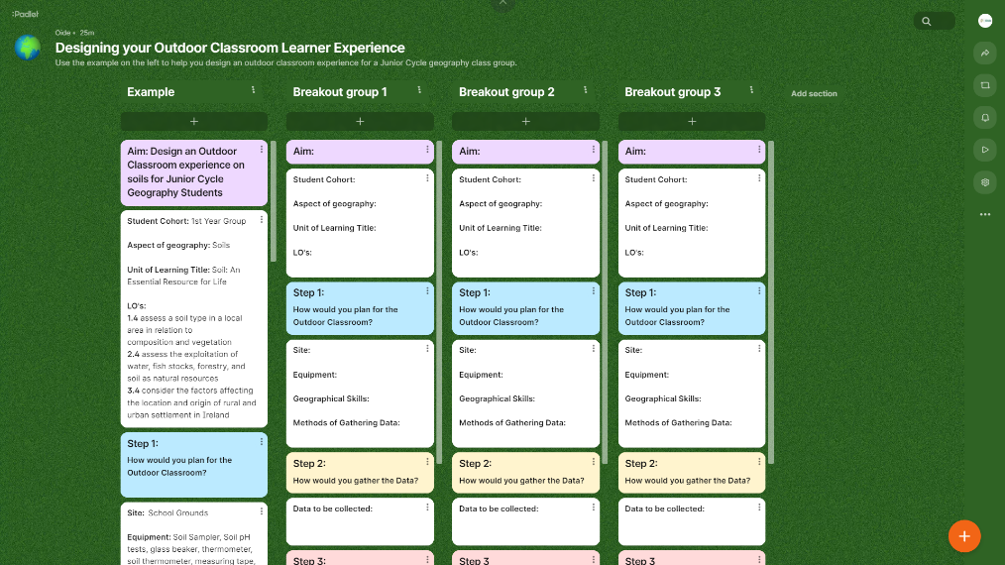](https://padlet.com/jct2/designing-your-outdoor-classroom-learner-experience-e7sh0yyngwik8kfl)

<https://padlet.com/jct2/designing-your-outdoor-classroom-learner-experience-e7sh0yyngwik8kfl>

# Survey 123 – Virtual Tour

Click on the images below to access our Survey 123 Virtual Tour.

This virtual tour of **Survey 123** from ArcGIS shows how to create interactive surveys. Survey 123 includes many survey features can generate surveys including:

* Geopoint map questions
* Ranking list questions
* Number range questions
* Data calculation questions

](https://www.thinglink.com/card/1438194581047869442)

<https://www.thinglink.com/card/1438194581047869442>

## Getting started with Survey 123 – Teach with GIS



<https://www.teachwithgis.ie/apps/c678b4afbead45019d4d42cce801bb59/explore>

# Senior Cycle Documents

## Draft Transition Year Programme Statement

Click on the image below to access the Draft Transition Year Programme Statement

[](https://www.curriculumonline.ie/getmedia/5849acbf-0326-487a-beec-3db6b5878470/TY-Programme-Statement-ENG-INT.pdf)

<https://www.curriculumonline.ie/getmedia/5849acbf-0326-487a-beec-3db6b5878470/TY-Programme-Statement-ENG-INT.pdf>

## Key Competencies in Senior Cycle

[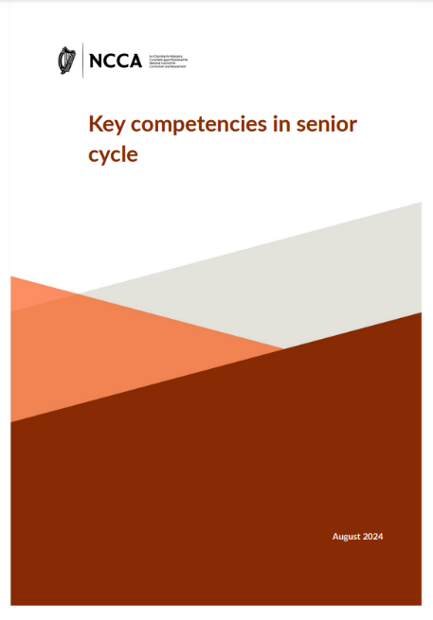](https://ncca.ie/media/mfhhagys/key-competencies-in-senior-cycle_en.pdf)

https://ncca.ie/media/mfhhagys/key-competencies-in-senior-cycle_en.pdf

# Reflecting on the Outdoor Classroom & Transition Year Geography

As you watch the video, consider the questions below:

|  |
| --- |
| **What are your takeaways from this video?** |
|  |
| **How would you incorporate the Outdoor Classroom into Transition Year Geography for your students?** |
|  |

# Transition Year Module Template

**Fill in the sample template below.**

|  |  |
| --- | --- |
| **Click here to enter TY Module Title** | |
| **Overview:** (The overview is a short statement describing the TY module. It should simply express the essence of the module) | **Related Learning:** (How the learning links back to Junior Cycle and forward to the Leaving Certificate and with other TY modules.) |
| **Cross-Curricular Links:** | |
| **Learning Outcomes:** (Brief, clear, specific statements of the knowledge, understandings, skills, values, and attitudes which it is expected students, will be able to demonstrate as a result of the learning associated with the module.) | |

|  |
| --- |
| **Key Competencies & Skills:** (The types of skills that students will encounter through participating in the module.) |
|  |

|  |  |
| --- | --- |
| **Teaching & Learning Approaches: (A key feature of transition year should be the use of a wide range of active learning methodologies and learning settings.)** | |
|  | |
| **Assessment Approaches: (Assessment should be built into the teaching and learning of each Transition Year module. Assessment can be formative or summative)** | |
| **Ongoing Formative Assessment Approaches:** | **Evidence of Learning & Student Role:** |
| **Module Resources:** | **Teacher notes:** |

|  |
| --- |
| **Evaluation:** (the purpose of evaluating the Transition Year module is to find out, both from the students’ and the teachers’ perspective, the success or otherwise of the module and how it can be improved for the future. Evaluation occurs during and after the completion of the TY module)  What worked well?  What can be improved?  How can it be improved? |

# Teacher Activity: Planning a TY Module

**Within Geography departments work collaboratively to design:**

* A TY module incorporating the **Outdoor Classroom** to engage **in the local area.**
* Supports students’ understanding of **geographical concepts.**
* **Develops** student’s **geographical skills.**

Click on the image below to access our Transition Year Module Planning Options

<https://www.canva.com/design/DAGDbgm5UUg/xXhy9tXMmErFrEmWUsmfNA/view?utm_content=DAGDbgm5UUg&utm_campaign=share_your_design&utm_medium=link&utm_source=shareyourdesignpanel>

# Transition Year Resources

|  |  |  |  |
| --- | --- | --- | --- |
| **Resource** | **URL** | **Description** | **How could I use this with my TY Geography students?** |
| [A logo of a planet  Description automatically generated](https://www.globe.gov/web/ireland/home/overview-of-air-quality-campaign) | <https://www.globe.gov/web/ireland> | The Global Learning and Observations to Benefit the Environment (GLOBE) Programme is an international science and education programme that provides school students with the opportunity to participate in citizen science. GLOBE is managed by An Taisce in partnership with the EPA. |  |
|  | <http://tourisminsight.ie/> | This free interactive online programme provides valuable tourism insights to transition year students and other learners, informing them of career options within the tourism industry. |  |
|  | <https://youth.europarl.europa.eu/more-information/ambassador-school.html> | The European Parliament Ambassador School Programme (EPAS) programme gives students the opportunity to understand their rights as EU citizens and to learn about the role of the European Parliament. |  |
|  | <https://www.teachwithgis.ie/apps/0d648c124c474d7298cdd08c9c7d5a20/explore> | Esri Ireland's TY GIS Module. Provides a collection of Story Maps to guide you through the GIS module. |  |
|  | <https://www.worldwiseschools.ie/> | WorldWise Global Schools is Ireland’s national Global Citizenship Education programme for post primary schools. |  |
|  | [https://schools.fairtrade.org.uk/teaching-resources/#page-1](https://schools.fairtrade.org.uk/teaching-resources/%23page-1) | Fair Trade Schools provides resources to teach Fair Trade in your school. |  |
| National Folklore Collection UCD ... | <https://duchas.ie/en> | This website is a digitization of the National Folklore Collection (NFC). The public has online access to material from the Collection and other material can be added in the future. |  |
| logainm.ie | Placenames Database of Ireland | <https://www.logainm.ie/ga/> | The Placenames Database of Ireland: This is a comprehensive record of the placenames records and research of the State. It is a public resource for Irish people at home and abroad, and for all those who appreciate the rich heritage of Irish placenames. |  |

# Geography Resources

This Padlet wall is where geography resources can be shared by everyone attending today. This could be an excellent resource going forward that will support you with the learning and teaching of geography. More importantly this Padlet can be added to at any time which will create a huge bank of resources that we be of support to you

[Click on the image of the Padlet below to open it online](https://padlet.com/jct2/geography-resources-xw3qvrds6xweyvb).

[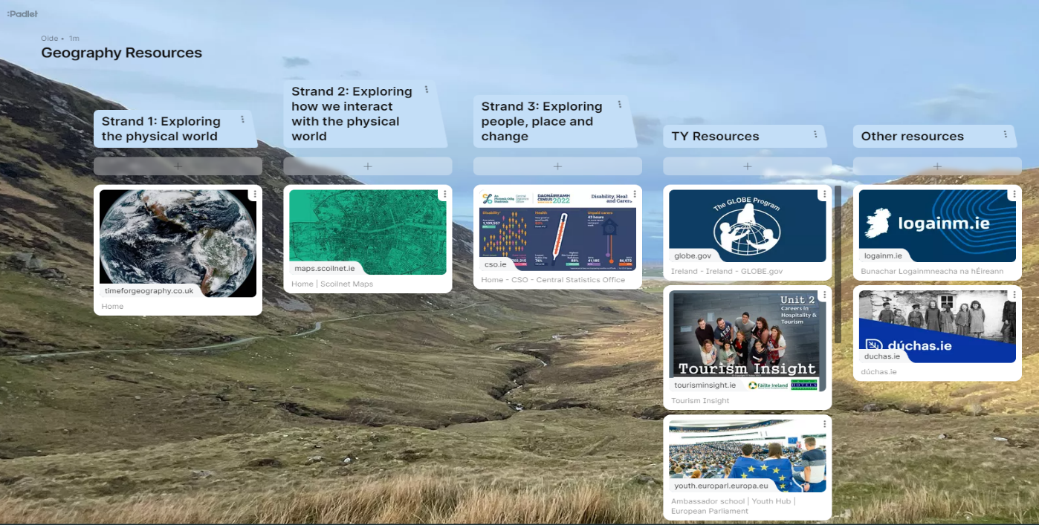](https://padlet.com/jct2/geography-resources-xw3qvrds6xweyvb)

# Reflecting on the Day

|  |
| --- |
| 1. What are the benefits of using the Outdoor Classroom with your geography students? |
| 1. What challenges do you foresee in using the Outdoor Classroom with your geography class? |
| 1. Consider how the Outdoor Classroom will enhance your students’ skill set for life |

# References

Junior Cycle Geography Specification, NCCA, (2017

Embracing Ireland’s Outdoors National Outdoor Recreation Strategy 2023-2027, Department of Rural and Community Development.

Living and Learning outside the classroom – fieldwork, Turney, A (2009)

Fieldwork, Geographical Association, (2024)

Audio-Visual Methods in Teaching (3rd ed), Dale, E., (1969).

Exceptionally Able Students Draft Guidelines for Teachers, NCCA, (2007)

Differentiating Curriculum for Gifted Students, Berger Davidson, Sandra. (1991)

Motivation and Gifted students: Implications of theory and research, Clinkenbeard, Pamela, R. (2012)

Transition Year Programme Statement, NCCA, (2024)

Key competencies in senior cycle (draft), NCCA, (2024)

Developing Transition Year Units, Draft Handbook for Schools, NCCA, (2008)

# Notes

________________________________________________________________________________________________________________________________________________________________________________________________________________________________________________________________________________________________________________________________________________________________________________________________________________________________________________________________________________________________________________________________________________________________________________________________________________________________________________________________________________________________________________________________________________________________________________________________________________________________________________________________________________________________________________________________________________________________________________________________________________________________________________________________________________________________________________________________________________________________________________________________________________________________________________________________________________________________________________________________________________________________________________________________________________________________________________________________________________________________________________________________________________________________________________________________________________________________________________________________________________________________________________________________________________________________________________________________________________________________________________________________________________________________________________________________________________________________________________________________________________________________________________________________________________________________________________________________________________________________________________________________________________________________________________________________________________________________________________________________________________________________________________________________________________________________________________________________________________________________________________________________________________________________________________________________________________________________________________________________________________________________________________________________________________________________________________________________________________________________________________________________