Personal Care Scenarios

Student is having difficulty understanding physical and emotional changes during puberty.  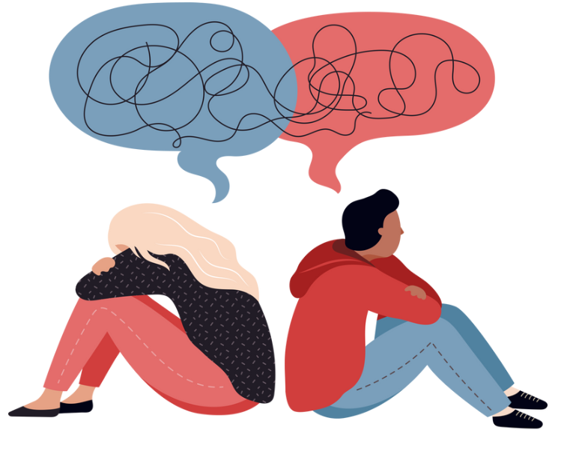 | Experiences discomfort with the sensation, taste and texture and smell of most foods. Has a very limited number of food preferences.  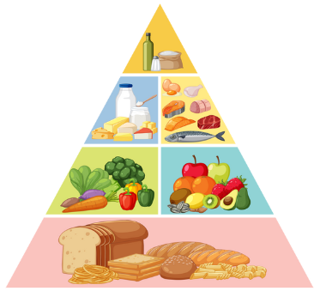 | Difficulty in establishing and maintaining a daily hygiene routine and doesn’t understand the social importance of cleanliness.  

Difficulty grasping what a period is, why it happens, or how to manage it  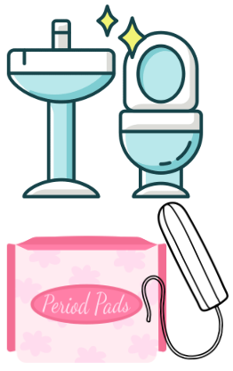 | Finds it difficult to identify and verbalise their emotions, leading to social isolation, misunderstanding and/or disagreements with peers and staff.  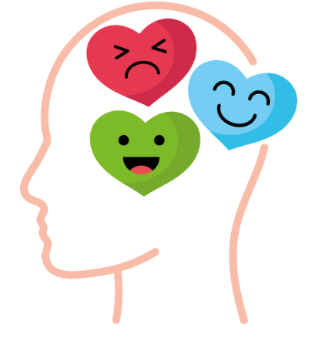 | Struggles to say “No!”  

Underestimates potential risks in an environment and doesn’t adjust behaviour based on safety guidance.   | Difficulty recognising physical contact requires consent and varies depending on the relationship.   | Struggles to differentiate between safe and unsafe online social behaviour.  

Aversion to the smell, noise, or feel of toilets (e.g., flushing sounds, cold seats).   | Not understanding social rules about and private vs. public behaviours   | Trouble choosing appropriate clothing for weather, activities, or body changes (e.g., bras, clean underwear, swimwear).  