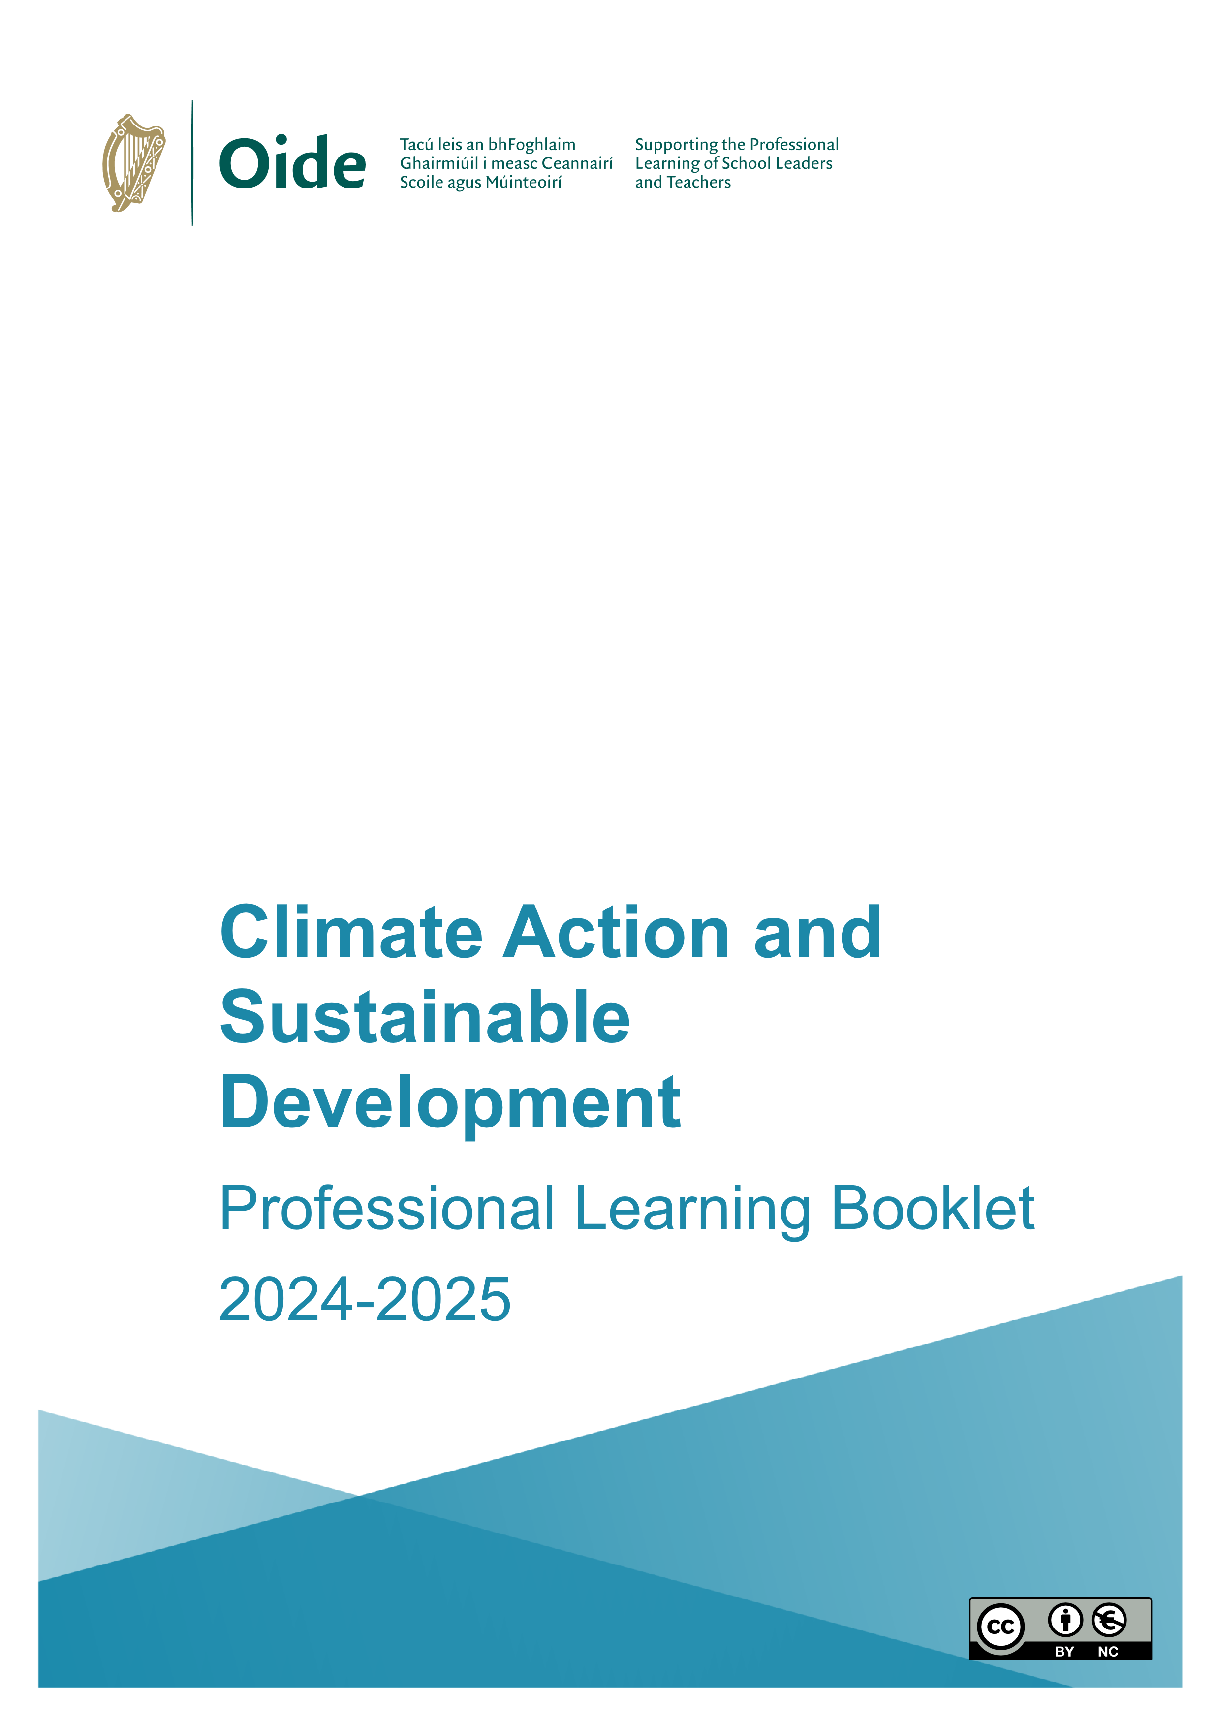

**Contents**

Senior Cycle Documents 2

Structure of Curriculum Specification for Leaving Certificate Climate Action and 4

Sustainable Development 4

Sharing of Resources 5

Key Competencies 6

Identifying themes 7

Ice Breaker 8

8

School Locations 9

Teacher Activity: Think – Pair – Share 10

Teacher Activity: Matching Activity 11

The Sustainable Development Goals 12

https://sdgs.un.org/goals 12

Understanding Sustainable Development in Ireland 12

Teacher Reflection Activity 13

Climate Justice / Injustice Key Concepts 14

Teacher Activity: What do you see? 16

Teacher Activity: Voices of the Congo 17

Teacher Activity: Voices of the Congo – Role cards 18

Stakeholder Profiles: 18

Teacher Activity: Organise Action 20

Teacher Reflection Activity 21

Teacher Activity: How did we plan? 22

Teacher Activity: Learner Experience 23

Teacher Reflection Activity 24

References 25

Notes 26

# Senior Cycle Documents

](https://ncca.ie/media/mfhhagys/key-competencies-in-senior-cycle_en.pdf)<https://www.curriculumonline.ie/getmedia/df1d6c85-f630-436f-9383-7503b64d6ed5/SC-Climate-Action-Sustainable-Dev-Spec-ENG.pdf>

<https://ncca.ie/media/mfhhagys/key-competencies-in-senior-cycle_en.pdf>

# Structure of Curriculum Specification for Leaving Certificate Climate Action and

# Sustainable Development

# Sharing of Resources

This Padlet wall is where Climate Action and Sustainable Development resources can be shared by everyone attending today. This could be an excellent resource going forward that will support you with the learning and teaching of Climate Action and Sustainable Development.

# 

[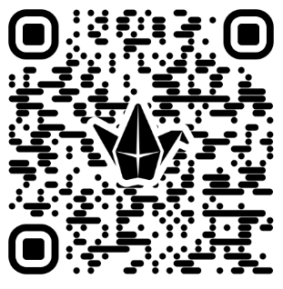](https://padlet.com/jct2/climate-action-sustainable-development-resources-b33bf91jyl3hqxn6)

<https://padlet.com/jct2/climate-action-sustainable-development-resources-b33bf91jyl3hqxn6>

# Key Competencies

# Identifying themes



As you watch the video reflect on the following:

**What stand out to you as you watch the video?**

# Ice Breaker

# 



# 

# 

# 

|  |
| --- |
| **Where are you from?** |
| **Experience?** |
| **What excites you about this subject?** |

# School Locations

The maps below show the locations of each person attending today's workshop

# Teacher Activity: Think – Pair – Share



|  |
| --- |
| **What is Climate Action and Sustainable Development?** |
| **Who is Climate Action and Sustainable Development for?** |

# Teacher Activity: Matching Activity



|  |
| --- |
| **Which strand were you working on?** |
| **What was the difference between the LO column and the SLA column?** |
| **How did the action verb help you approach the Learning Outcome?** |

# 

# The Sustainable Development Goals

[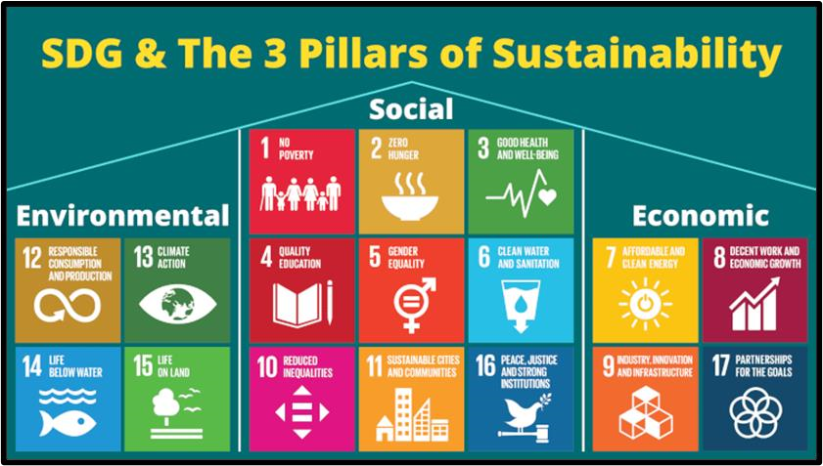](https://sdgs.un.org/goals)

## <https://sdgs.un.org/goals>

# Understanding Sustainable Development in Ireland

[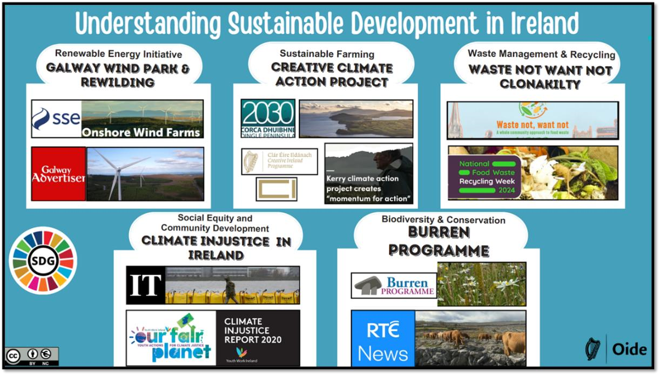](https://www.canva.com/design/DAGRqIUxm2s/zVK7u7PyH5FRCOAD8qkugg/view?utm_content=DAGRqIUxm2s&utm_campaign=designshare&utm_medium=link2&utm_source=uniquelinks&utlId=h41aa54ea32)

<https://www.canva.com/design/DAGRqIUxm2s/zVK7u7PyH5FRCOAD8qkugg/view?utm_content=DAGRqIUxm2s&utm_campaign=designshare&utm_medium=link2&utm_source=uniquelinks&utlId=h41aa54ea32>

# Teacher Reflection Activity

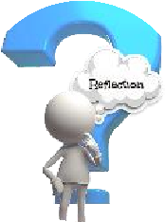

**Which concept or skill from today are you most excited to implement?**

# 

# Climate Justice / Injustice Key Concepts

[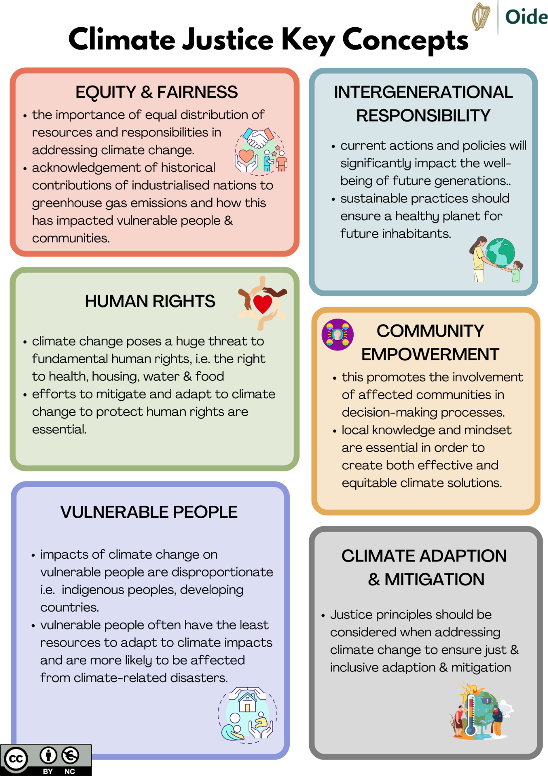](https://www.canva.com/design/DAGTvh84nzE/sJAytpFDEVFTizrST42fGw/view?utm_content=DAGTvh84nzE&utm_campaign=designshare&utm_medium=link2&utm_source=uniquelinks&utlId=hefc84521b6#1)

[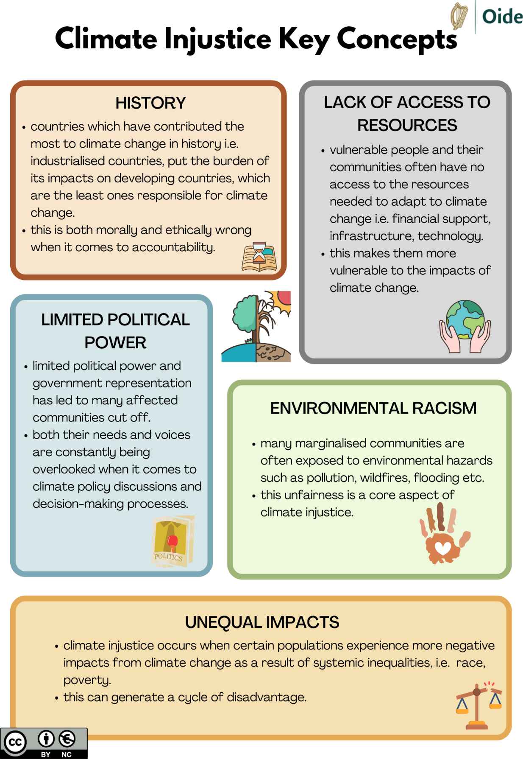](https://www.canva.com/design/DAGTvh84nzE/sJAytpFDEVFTizrST42fGw/view?utm_content=DAGTvh84nzE&utm_campaign=designshare&utm_medium=link2&utm_source=uniquelinks&utlId=hefc84521b6#1)

<https://www.canva.com/design/DAGTvh84nzE/sJAytpFDEVFTizrST42fGw/view?utm_content=DAGTvh84nzE&utm_campaign=designshare&utm_medium=link2&utm_source=uniquelinks&utlId=hefc84521b6#1>

# Teacher Activity: What do you see?



|  |
| --- |
| **What do you see?/ What do others see?** |
| **What made you say that?** |

# Teacher Activity: Voices of the Congo



](https://www.canva.com/design/DAGRU3pA0Z0/xoq8fjVmgdSTEj2R184XaA/view?utm_content=DAGRU3pA0Z0&utm_campaign=designshare&utm_medium=link2&utm_source=uniquelinks&utlId=h30b0502931)

[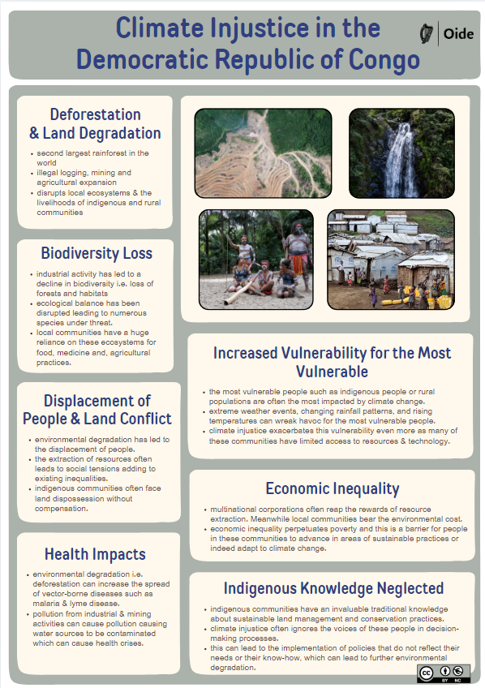](https://www.canva.com/design/DAGRk_JMbfQ/qRRs21at0CaD3j7XooBNfg/view?utm_content=DAGRk_JMbfQ&utm_campaign=designshare&utm_medium=link2&utm_source=uniquelinks&utlId=h56795fcc8c)

<https://tinyurl.com/bd93txjp> <https://tinyurl.com/57mea35c>

[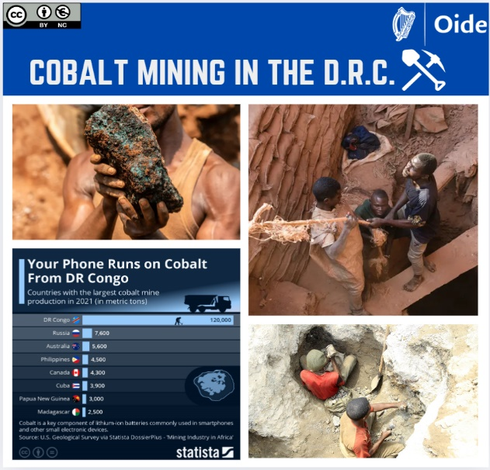](https://www.canva.com/design/DAGRqEqVQBU/j7x6hrA0DxEY2prdQRQyYw/view?utm_content=DAGRqEqVQBU&utm_campaign=designshare&utm_medium=link2&utm_source=uniquelinks&utlId=ha0aa3eb485)

<https://tinyurl.com/3c2asvsf>

# Teacher Activity: Voices of the Congo – Role cards

## Stakeholder Profiles:

**Scenario: Should the mining company be granted a licence for this mine?**

Each stakeholder

* Considers the opportunities and concerns from the mine presents for them
* Decides on whether the mine should be granted a licence?
* Prepares a brief presentation or statement from their perspective, outlining their **concerns, proposed actions, and solutions**.
* Presents their position to the entire group

|  |
| --- |
| **Local Teenager:**    I live with my mother and two younger brothers and two sisters. I’ve left school to help my family because money is always scarce, and we often just have one meal a day. I have heard a mine might open near my village and I would hope to get a job there.  Many of my friends have gone off to work in mines and I hear you will be paid 7500  CF ($3.75 US) per bag mined. Bread for two people for a day costs 4500 CF in the DRC. ($1.58). The government said employers should pay 7075 CF ($ 2.49) per worker per day but in practice many businesses are not paying this and they don’t face any penalties. I know the work in the mine is hard as you do it all day long and have to bend all the time. I want to do this work because I do not have any other way to make money unless I leave to find work in the capital city. My mother needs me here and my family need money to survive. I don’t want my mother or my little brothers and sisters to have to work in the mine, I hope I earn enough money so as they can stay in school. |
| **Government Official:**    I work for the Mines Ministry, which oversees the country's reserves of coltan, copper, and other minerals such as cobalt.  I am responsible for policy-making and balancing development with environmental protection. The DRC need money in the exchequer to improve infrastructure, education and to service international debt. We need to keep the economy growing and I’m aware that foreign investments could be moved to nearby countries if we do not stay competitive. The GDP has grown due to a strong mining sector, which grew by 15.4%, contributing around 70% to overall growth in 2023.  I welcome the opening of the new mine as it is going to provide job opportunities for people and generate some wealth for our country. |
| **International NGO:**    I have many years of experience working in the not-for profit sector. I have been based in the DRC for the last five years working for Concern. My work has been focused on providing aid and advocating for sustainable practices.  Over 25 million people — a quarter of the population - are facing acute food  insecurity. An estimated 74.6% of Congolese people lived on less than $2.15 a day in 2023. Many people work in terrible conditions in non-regulated mines known as artisanal mines. Their conditions resemble modern day slavery.  I am also concerned about the loss of biodiversity as rainforests are being cut down to make way for mines. I’ve seen rivers and soil contaminated near mining areas. |
| **Business Leader:**    I have opened some previous mines in the DRC and have developed supply chains with the international manufacturers of lithium batteries in China and Canada. The price of cobalt has dropped in recent years as some of the big companies are recycling their cobalt. I have a lot of costs as I need to pay my workers, buy equipment and pay for the mining licence. I must comply with government regulations for standards in the mines.  I have experienced some protests in recent times at my other mines from workers demanding higher wages and better conditions. If I don’t increase the supply by opening another mine, I won’t be able to afford to keep the original mines open. Many families rely on me to provide employment as other opportunities are limited. |
| **Farmer:**    I work hard on the farm with my husband to support my five children and to pay school fees. We often cannot afford three meals a day despite working long hours. In recent years we have suffered from flooding and draughts due to unpredictable rainy seasons. Malnutrition and hunger are commonplace in our village.  Last year I received training and seeds (maize, groundnut and cowpea) from an NGO and had a good harvest with enough to feed the family and sell a small proportion of crops. The quality and quantity of my produce improved, and I hope this will continue into the future. A new co-operative has been established and I hope to join. We rely on the local river to get clean water to irrigate the soil.  Farming is very important in our country as 60% of people work in this sector. |

# 

# Teacher Activity: Organise Action



|  |
| --- |
| **How would you guide your students to plan and design a potential action to address climate injustice?** |

# 

# Teacher Reflection Activity

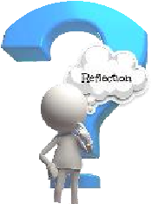

|  |
| --- |
| **Discuss how this activity has influenced your students understanding of climate justice/injustice?** |
| **How do you think your students understanding of global issues would be broadened if they were to undertake this activity?** |

# Teacher Activity: How did we plan?



|  |
| --- |
| **What competencies are experienced during this activity?** |
| **Which learning outcomes are engaged with across the strands?** |

# Teacher Activity: Learner Experience

* Create a **learner experience** on **Climate injustice** in **one** of the five locations:
* **Indonesia, Amazon - Brazil, Ireland, Chad.**
* Consider that the Learner Experience is:
  + Action based
  + Student centred
  + Enquiry led
  + Link Los across the strands
  + Possible link to ALT

# Teacher Reflection Activity



|  |
| --- |
| **What are your takeaways from today?** |
| **Consider your next steps in planning for the implementation of Climate Action and Sustainable Development.** |

# References

Curriculum Specification for Leaving Certification Climate Action and Sustainable

Development, NCCA, (2024)

Key competencies in senior cycle, NCCA, (2024)

The 17 Goals – Sustainable Development from [http://sdgs.un.org/goalsC](http://sdgs.un.org/goals)limate

Climate Change Climate Justice – Together we are the solution to clime injustice –

Education Resource Pack for Primary Schools Trócaire, (2015)

Principles of Climate Justice, Mary Robinson Foundation

Climate Justice Explained, Concern worldwide, (2022)

# 

# Notes

_____________________________________________________________________________________________________________________________________________________________________________________________________________________________________________________________________________________________________________________________________________________________________________________________________________________________________________________________________________________________________________________________________________________________________________________________________________________________________________________________________________________________________________________________________________________________________________________________________________________________________________________________________________________________________________________________________________________________________________________________________________________________________________________________________________________________________________________________________________________________________________________________________________________________________________________________________________________________________________________________________________________________________________________________________________________________________________________________________________________________________________________________________________________________________________________________________________________________________________________________________________________________________________________________________________________________________________________________________________________________________________________________________________________________________________________________________________________________________________________________________________________________________________________________________________________________________________________________________________________________________________________________________________________________________________________