

Insert School Crest

Droichead


Sample Induction Policy – Primary

Droichead – Sample Induction Policy - Primary

Contents

1. Introduction 2
2. Rationale 2
3. Aims 2
4. Roles and Responsibilities 3
4.1 Professional Support Team (PST) - Suggested Roles and Responsibilities 3
4.2 NQT - Suggested Roles and Responsibilities 4
4.3 Role of Principal - Suggested Roles and Responsibilities 5
5. Protocols 5
6. Supporting Documentation 6
7. Timetable for Review 6
8. Ratification and Communication 7
Appendix 1: PST Member Names 8
Appendix 2: PST and NQT - Roles and Suggested Responsibilities 9
Appendix 3:The Oversight Role of the Principal/Management Team Nominee – Suggested Responsibilities 14

Oide.ie

Introduction
The Droichead process is an integrated professional induction framework for newly qualified teachers (NQTs). It builds on Céim, taking as its starting point the areas for further learning that have been identified by the NQT in collaboration with the Higher Education Institution (HEI) as part of the school placement experience. At the same time, it recognises that induction is a distinct phase of the continuum of teacher education, a socialisation process into the teaching profession.
The main objective of Droichead is ‘to support the professional learning of the NQTs during the induction phase, in a non-evaluative manner, thus laying the foundations for subsequent professional growth and learning’ for the next phase of their career (Teaching Council, 2025, p.4).

Rationale
To provide a common understanding of Droichead for all school stakeholders.

Aims
The main aims of this policy are:
  - To guide the whole-school implementation of Droichead and to support the induction of NQTs
  - To outline the roles and clarify the responsibilities across the school community in support of Droichead
  - To highlight protocols underpinning Droichead in the school
  - To identify key documents which support Droichead

Roles and Responsibilities

Professional Support Team (PST) - Suggested Roles and Responsibilities
A PST is a team of experienced, fully registered teachers (which may include the principal) who have been trained by the Droichead Induction Division of Oide to support Droichead. The PST works collaboratively to support and guide the NQT through their induction phase.
The PST, comprising a minimum of two members, may be entirely school based. Alternatively, schools may nominate an external PST member. The external PST member may be a teacher from a local school or a teacher selected from a panel of trained PST members which is operated by the Droichead Induction Division. Another option for schools is to opt for an inter-school PST model, whereby a cluster of schools will form a single PST, made up of teachers from the cluster schools. At least one PST member must be from the base school. For further information on the external and inter-school models, please go to https://oide.ie/droichead/home/.
Supporting an NQT through Droichead is always a collaborative process. The dual role of the PST is to:
    - guide and advise the NQT during school-based induction, in the first stages of their professional journey
    - form a joint declaration with the NQT that, ‘through their engagement in Droichead, they have participated in a quality teaching and learning process’ (Teaching Council, 2025, p.4).
‘The roles and responsibilities of PST members may vary in different school contexts and are therefore agreed before the Droichead process commences’ (Teaching Council, 2025, p.9).
To guide a PST in its roles, some suggested responsibilities are identified in Appendix
2. The list is neither exhaustive nor prescriptive and is open to customisation by a PST. While the responsibilities of mentoring are common to all team members, a PST may designate some of the other responsibilities to identified individuals within the team.
The PST will share its roles and agreed responsibilities with the NQT at their initial meeting.
Appendix 1 details the names of each trained PST member in the school.
Appendix 2 outlines suggested roles and responsibilities for all PST members and suggested responsibilities that may be assigned to a named PST member.

NQT - Suggested Roles and Responsibilities
As previously stated, the main objective of Droichead is ‘to support the professional learning of the NQTs during the induction phase, in a non-evaluative manner, thus laying the foundations for subsequent professional growth and learning’ for the next phase of their career (Teaching Council, 2025, p.4).

NQT Role
Supporting an NQT through Droichead is always a collaborative process. Droichead is fundamentally about the NQT’s professional journey and the process of their induction. A key part of this process is an NQT’s engagement with more experienced colleagues, and reflection on the professional conversations that take place about their own professional learning and practice.
Through their engagement in Droichead, the NQT will, in line with the Droichead standards,
- have engaged professionally with school-based induction and additional professional learning activities
- have shown their professional commitment to quality teaching and learning for their pupils
- have engaged in reflective practice that supports their professional learning and practice, both individually and collaboratively.
Based on the above, the NQT will sign a joint declaration with the PST, that they have
‘participated in a quality teaching and learning process’ (Teaching Council, 2025, p.4).

Appendix 2 also outlines suggested roles and responsibilities for the NQT.

4.3 Role of Principal - Suggested Roles and Responsibilities
‘As a leader of learning in the school, the principal fosters a learning culture in which Droichead can flourish and supports the PST in facilitating a quality induction process’ (Teaching Council, 2025, p.15).
The principal also ‘plays a vitally important role in annually highlighting the value of induction to the whole school staff, as well as the PST and NQT (Teaching Council, 2025, p.9).
While many primary principals have opted to engage as a member of the school’s PST, they may alternatively opt solely for an oversight role, choosing to support the NQT and PST as they undertake Droichead, but not forming a part of the PST and not signing Form D.
‘It is important that schools have in-school management support for the induction process. The principal or their management team nominee should have oversight of the Droichead process in their school, whether a direct member of PST or not’ (Teaching Council, 2025, p.9).
Appendix 3 outlines suggested roles and responsibilities for a principal/management team nominee in an oversight role.

Protocols
This Induction Policy advocates adherence to the protocols identified in Droichead – The Integrated Induction Framework (Teaching Council, 2025). This policy is specifically supported by the protocols referenced in the following sections:
  - Professional Conversations: p.10
  - Observation: p.11
  - Maintaining Droichead records: p.13
  - Concluding the Droichead process: p.14

Supporting Documentation
This policy is part of a suite of documents to support Droichead in the school. The Teaching Council's supporting documentation includes:
  - Droichead: The Integrated Professional Induction Framework, March 2025
  - Code of Professional Conduct for Teachers Updated Second Edition, 2016
  - Cosán: Framework for Teachers Learning, March 2016
  - Post-qualification Professional Practice Procedures and Criteria
  - Registration Handbook
  - Transitionary Arrangements Post-Qualification Professional Practice Conditions

The Department of Education and Youth’s supporting documentation includes:
  - Looking at Our School 2022: A Quality Framework for Primary Schools and Special Schools (LAOS) Department of Education, Updated January 2024

The Oide Droichead Induction Division’s supporting documentation includes:
  - Droichead – Outline Plan – Primary (to be drafted by the PST and finalised with NQT input)
  - PST and NQT Roles and Responsibilities
  - Droichead - Standards and Induction Plan - Primary (to be utilised in conjunction with LAOS 2022, and updated regularly in collaboration with the NQT)

Timetable for Review
This policy will be subject to annual/biannual review which will be informed by ongoing experiences. The review of the policy will be led by the principal in collaboration with members of the PST and the NQT(s) and the in-school management team.

Ratification and Communication
This policy was formally ratified by the Board of Management of XXXX school at its meeting held on ______________________

The policy is next due for ratification on/in

A copy of the policy is available

Signed _______ (Chairperson Board of Management)

Date _____

Signed ___(Principal)

Date

Appendix 1: PST Member Names

PST Members’ Details (Please edit as appropriate)

Name | Class/Role | Droichead Induction Division

Appendix 2: PST and NQT - Roles and Suggested Responsibilities

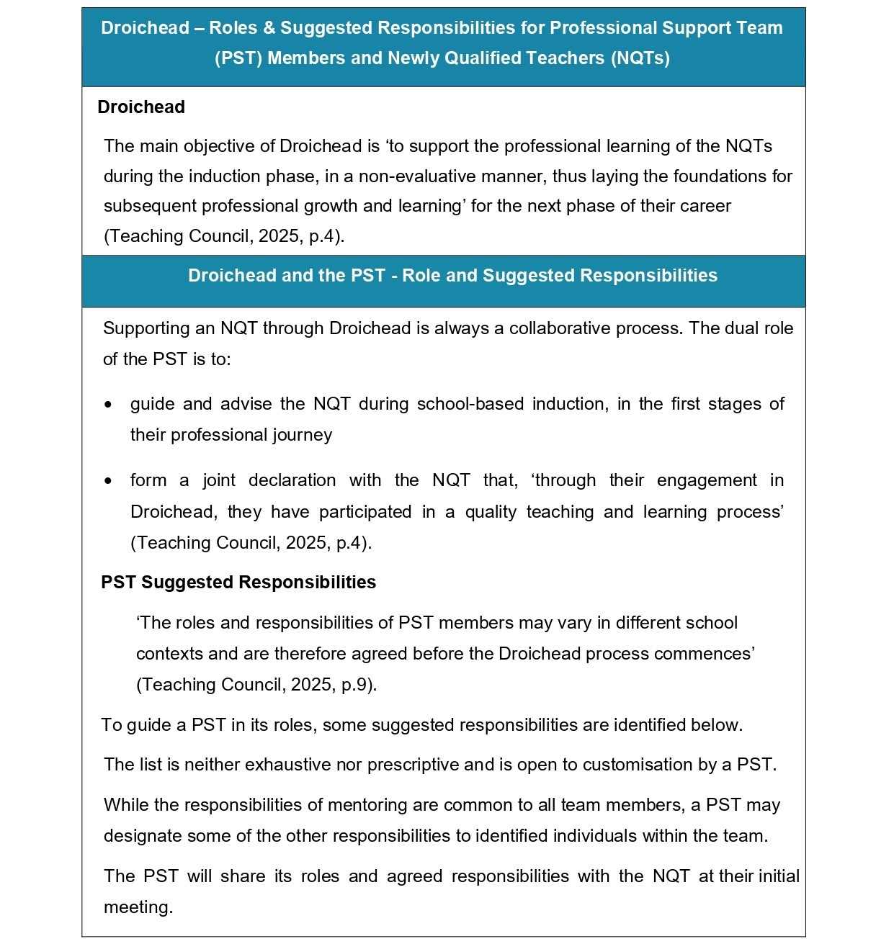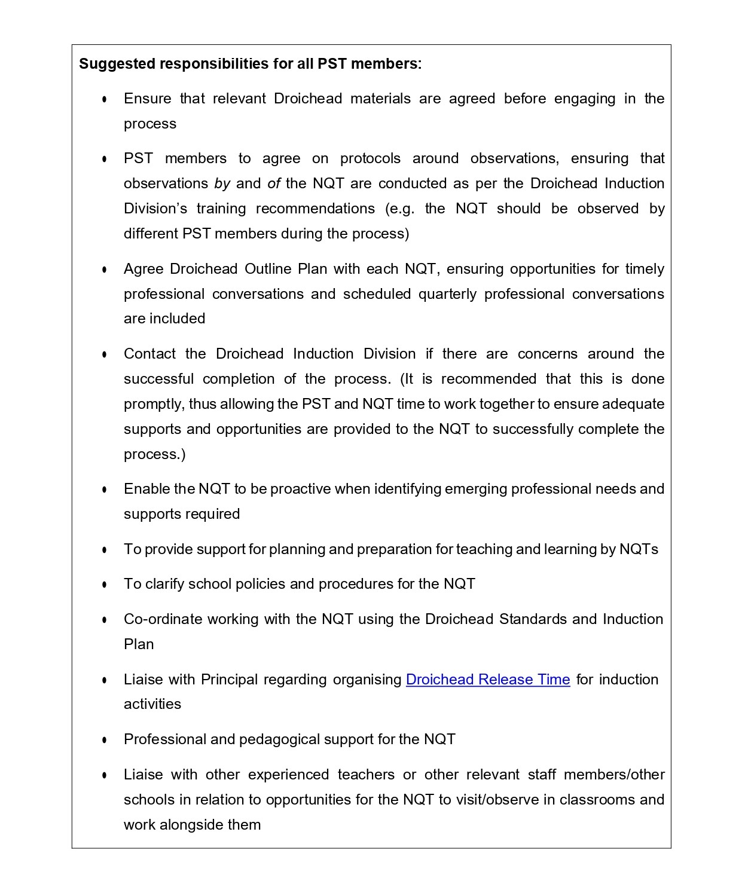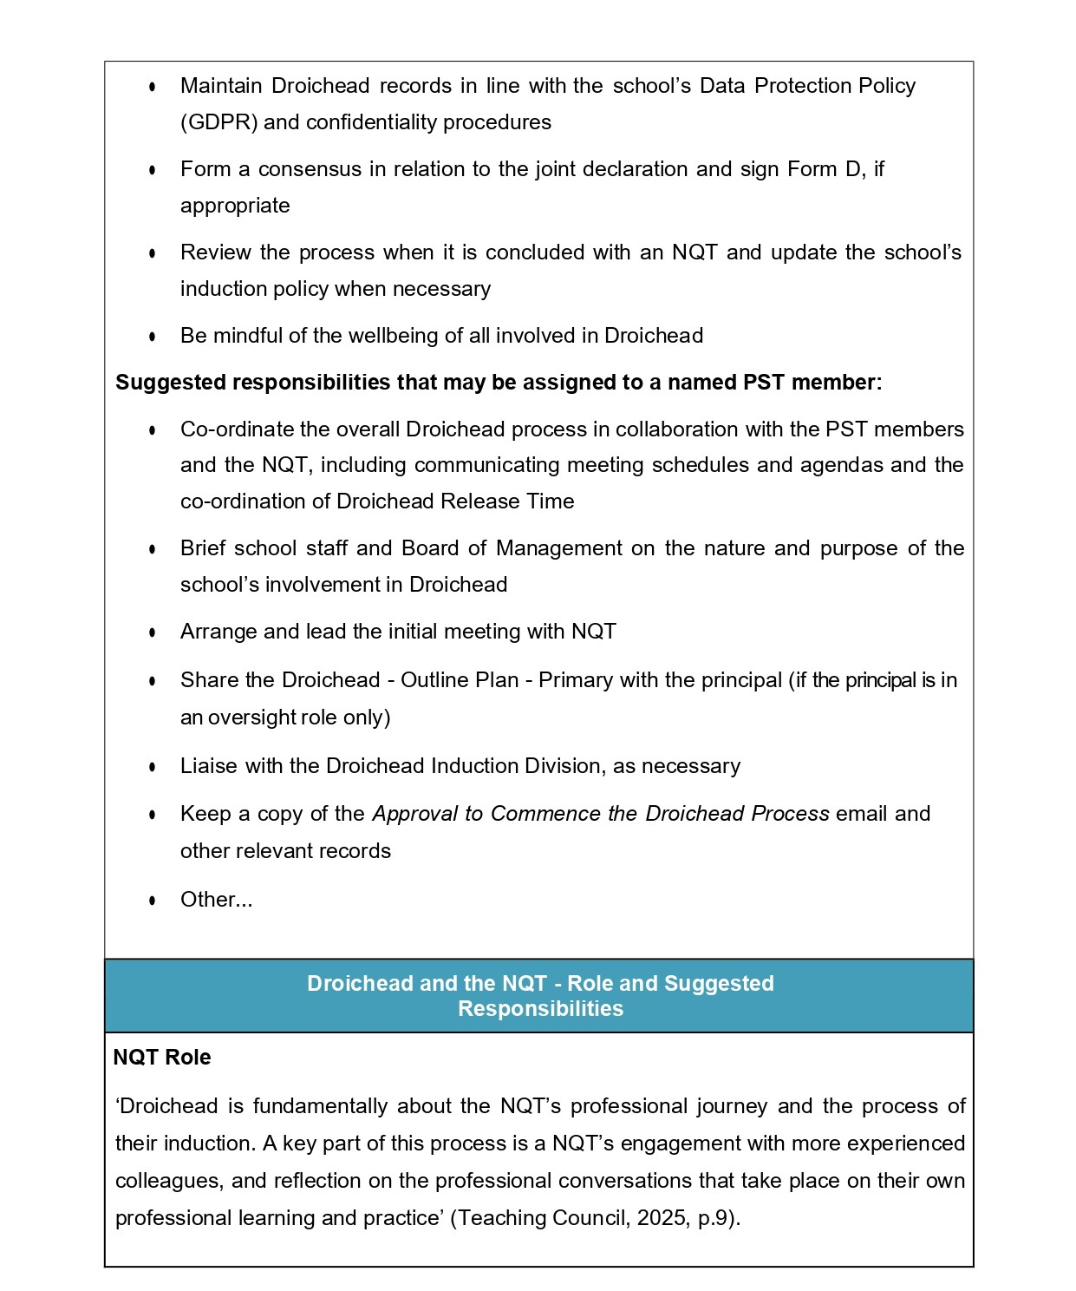
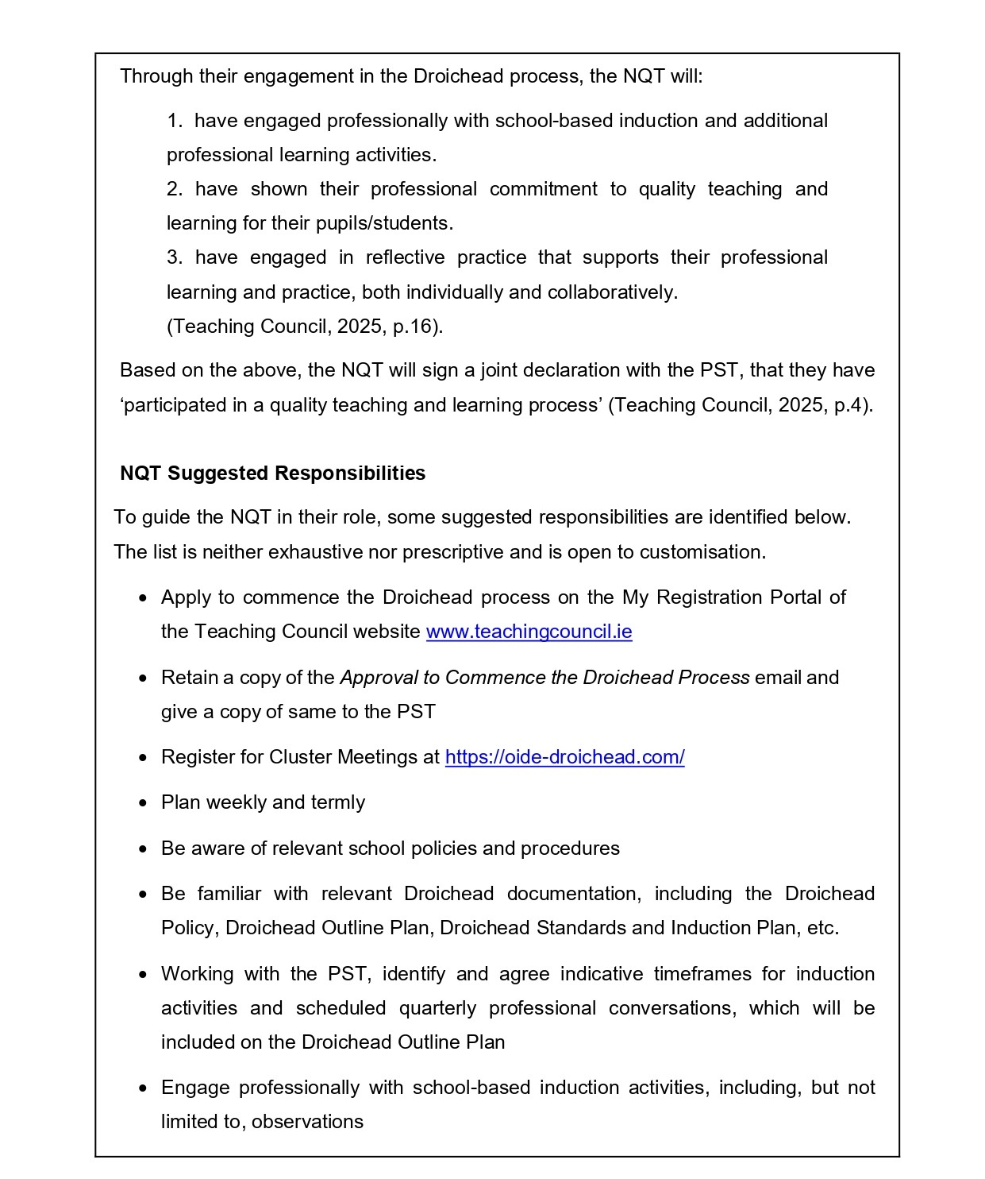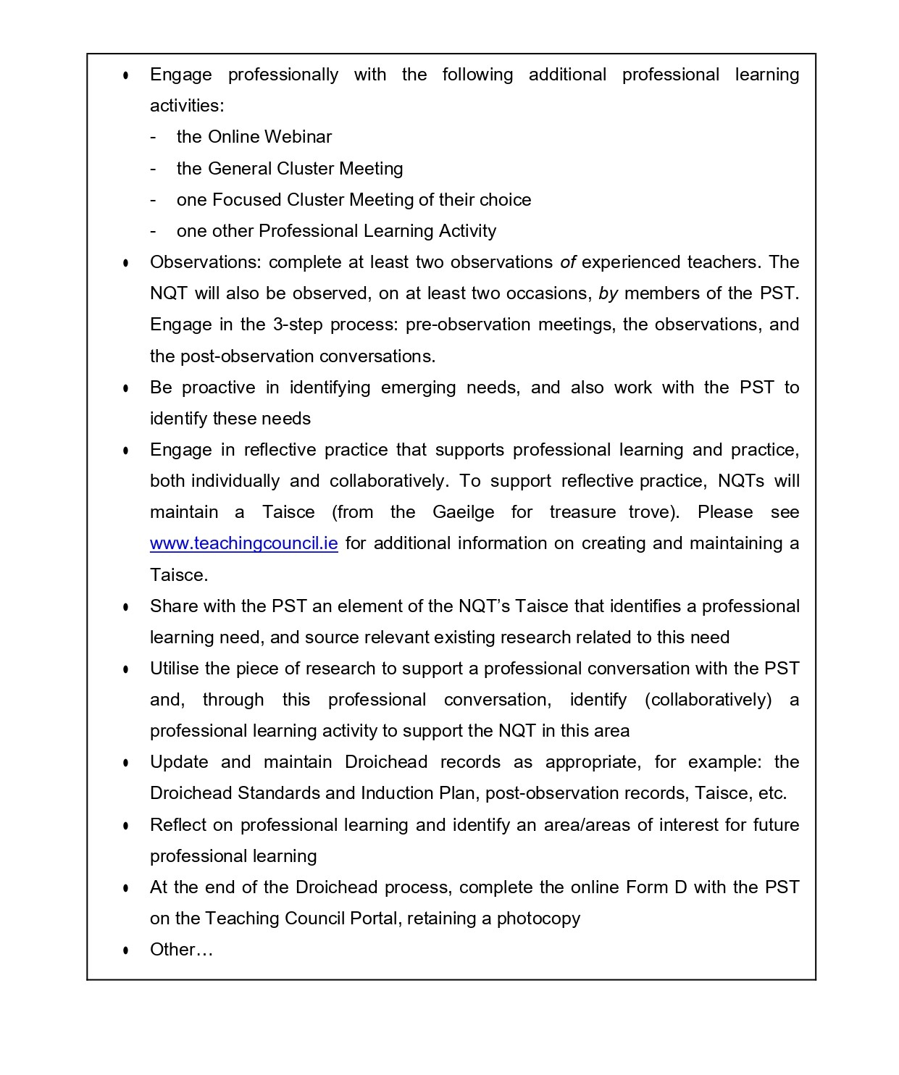

Appendix 3: The Oversight Role of the Principal/Management Team Nominee - Suggested Responsibilities

